Outreach Packet: English Learner Family Toolkit and App
The U.S. Department of Education’s Office of English Language Acquisition (OELA) has developed this outreach packet to provide sample communications for the English Learner Family Toolkit and the English Learner Family Toolkit mobile app. Within this outreach packet, you’ll find marketing materials tailored to assist with your various outreach needs. For any inquiries, please feel free to reach out to us at askncela@manhattanstrategy.com.

English Learner Family Toolkit Webinar: An Overview
To learn more about the English Learner Family Toolkit, check out this webinar recording and the slides used during the presentation. Presenters covered all six chapters, discussed toolkit usage, and listed the best practices for sharing these resources with English learner (EL) families.

Social Media Handles and Hashtags
Be sure to like and follow OELA online and tag us in your social media posts with the following accounts and hashtags:
- X (Formerly Known as Twitter): @ASKNCELA1
- Facebook: @ED.OELA
- LinkedIn: https://www.linkedin.com/company/ed-oela
- Hashtags: #OELA, #ELFamilyToolkit, #ELFamilyToolkitApp

Overview of Outreach Materials
- Newsletter Insert Examples
- Social Media Posts Examples
- FAQs Blog
- Graphics

Newsletter Insert Examples

#1 Engaging Families:
Exciting news from the Office of English Language Acquisition (OELA) of the U.S. Department of Education! OELA has recently launched an updated version of the English Learner (EL) Family Toolkit, along with a free EL Family Toolkit app. Tailored for parents, caregivers, families, and guardians, these free resources from OELA will keep you seamlessly connected to the latest tips and practical resources.
The toolkit provides valuable insights about U.S. schools, your rights, enrollment policies, and available programs and extracurricular activities for your child.
The app is available in English, Spanish, Chinese, and Arabic for both Android and Apple devices. To download the app, simply search for “EL Family Toolkit” in your app store.

#2 Informing Educators:
Notifying all teachers, administrators, and educational staff! The U.S. Department of Education's Office of English Language Acquisition has recently launched an updated English Learner (EL) Family Toolkit and an accompanying EL Family Toolkit app.
The EL Family Toolkit app provides ELs with access to quality educational opportunities and keeps educators informed of the latest professional development resources from the U.S. Department of Education. The app also offers practical tips for educators on how to use the toolkit to connect with families effectively. It is a free resource that aims to enhance support for ELs and their families.
The app is available in English, Spanish, Chinese, and Arabic for both Android and Apple devices. To download the app, simply search for “EL Family Toolkit” in your app store.

Social Media Post Examples

X (Formerly Known as Twitter):
- The #ELFamilyToolkit helps families and educators stay connected to the latest tips, tools, and practical resources to support ELs enrolled in U.S. schools. Download this FREE resource today!
App Store: https://ow.ly/kBBW50QfFBc
Google Play: https://ow.ly/WrK850QfFBb
- Discover OELA's app for the #ELFamilyToolkit, offering tailored support to families with English learners. Access all six chapters in four languages, bookmark chapters for future use, and explore resources.
Find it in your app store by searching “EL Family Toolkit.”

Facebook/LinkedIn:
- The English Learner Family Toolkit helps families and educators stay connected to the latest tips, tools, and practical resources to support English learners enrolled in U.S. schools. Download this FREE resource today! #ELFamilyToolkit
App Store: https://ow.ly/kBBW50QfFBc
Google Play: https://ow.ly/WrK850QfFBb
- Discover OELA's app for the English Learner Family Toolkit, offering tailored support to families with English learners. Access all six chapters in four languages, bookmark chapters for future use, and explore resources.
Find it in your app store by searching “EL Family Toolkit.”

EL Family Toolkit and App: FAQs Blog
Read our blog to discover answers to frequently asked questions for navigating the toolkit and the recently launched app.

Graphics
The following graphics can be used with the newsletter messages and social media posts above.
Twitter | Facebook, LinkedIn
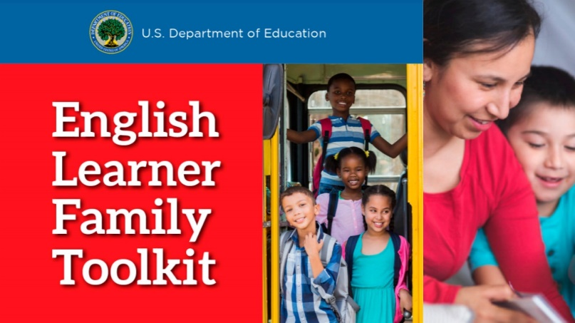 | 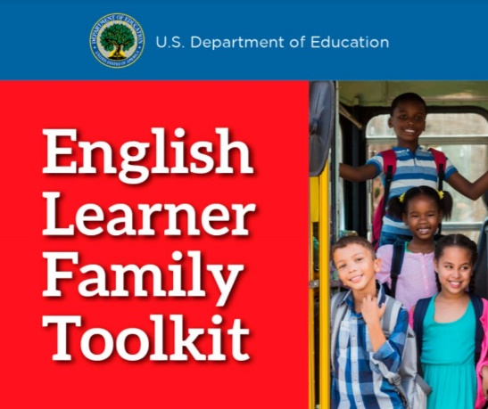
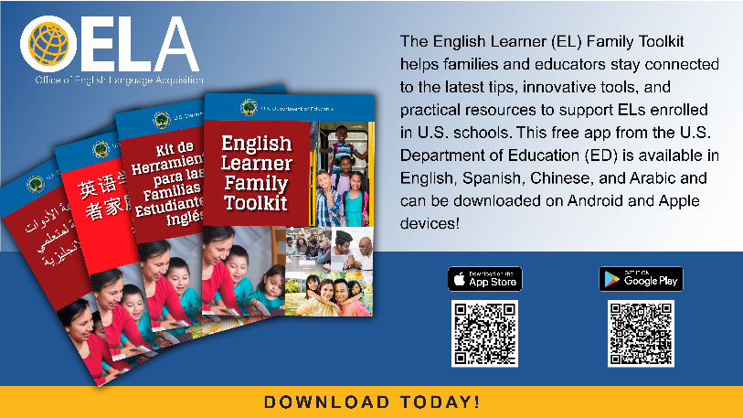 | 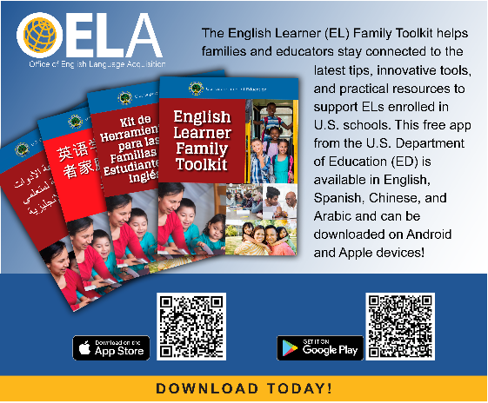
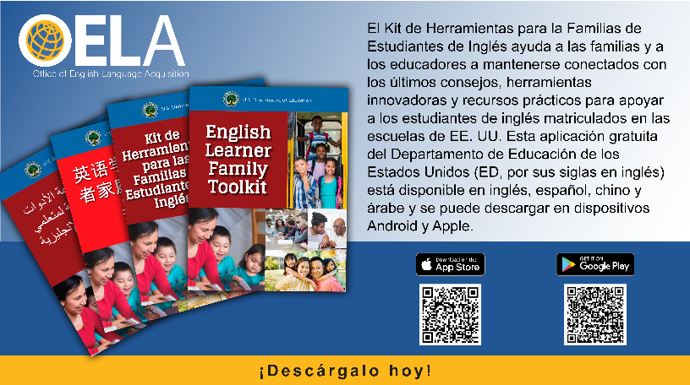 | 