Voters in Arkansas Tourist Town Uphold Anti-Discrimination Law
By RICHARD FAUSSETMAY 13, 2015
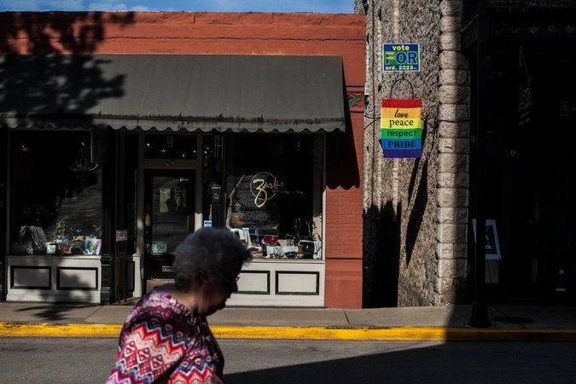

A sign in downtown Eureka Springs, Ark., where residents voted Tuesday to uphold an ordinance to prevent discrimination based on sexual orientation or gender identity. CreditAndrea Morales for The New York Times
Residents in the small Arkansas tourist town Eureka Springs voted Tuesday to uphold an ordinance to prevent discrimination based on sexual orientation or gender identity, rejecting an argument by opponents that the measure could harm tourism and force churches to host same-sex weddings and receptions.
Jamie Correia, the Carroll County clerk, said 579 people voted to uphold the law and 231 voted to strike it down, according to an unofficial tally.
The result in Eureka Springs, a city considered a liberal outlier in the Ozarks region, is a small but welcome one for gay rights activists in Arkansas, and reflects the complicated push and pull that has characterized broader gay rights issues in the state over a tumultuous year
Last May, Judge Chris Piazza, of Arkansas’s Sixth Judicial Circuit, invalidated the state ban on same-sex marriage, and the unions were allowed for seven days, until the ruling was stayed by the Arkansas Supreme Court.
On April 1, Gov. Asa Hutchinson, a Republican, declined to sign legislation billed as a religious freedom measure that had been opposed by gay rights advocates and businesses including Walmart, the state’s largest employer.
Mr. Hutchinson later signed a version of the bill that was altered to closely mirror a federal law approved in 1993.
The Eureka Springs City Council unanimously approved its anti-discrimination ordinance in February. Members said they were reacting to the Republican-dominated state legislature, and a law it eventually passed prohibiting local governments from enforcing their own anti-discrimination laws.
That law will take effect later this summer and Mayor Robert Berry of Eureka Springs has said that it will probably render the local ordinance unenforceable. But advocates said they hoped it could be used as a basis to challenge the state law in court.
“Where leadership has failed Arkansas on the state level, local municipalities like Eureka Springs have taken the initiative to ensure that all their residents are rightfully protected from all forms of discrimination,” Kendra R. Johnson, Arkansas state director of the Human Rights Campaign, a national gay rights group, said in a prepared statement released late Tuesday.
The group noted that both Little Rock and Hot Springs, Ark., had passed anti-discrimination ordinances. But those protect only employees and city contractors, the group said, while the Eureka Springs law covers all citizens.
The debate in Eureka Springs over the ordinance had become intensely personal, with strong religious overtones. Supporters and opponents made phone calls and knocked on doors in an effort to persuade friends and neighbors to vote. “The Great Passion Play,” a dramatic retelling of the story of Jesus Christ, and one of the region’s most notable tourist attractions, is just outside the city limits. Opponents of the ordinance said the measure and a more gay-tolerant atmosphere were making Christians think twice about visiting.
Travis Story, a Fayetteville, Ark., lawyer who acted as lead legal counsel for the group that opposed the ordinance, said he and his allies were now considering challenging it in a state or federal court.
“Now is the time to look at the constitutionality of the actual ordinance, because I think there are issues with the way it is written,” Mr. Story said.
Voters recently rejected similar anti-discrimination ordinances in nearby Fayetteville and Springfield, Mo.

http://www.nytimes.com/2015/05/13/us/voters-in-arkansas-tourist-town-uphold-anti-discrimination-law.html?ref=topics

