TASC Mathematics
Detailed Description and Sample Problems for Algebra
Approximately 26% of the Math on the TASC is Algebra.

The following pages list the algebra standards assessed on the TASC and a sample question for each standard. Also noted is whether each standard is a high, medium or low emphasis topic on the TASC.

The algebra standards are divided into the following four sub-domains:
- Reasoning with Equations and Inequalities (9 standards) – 8%
- Creating Equations (4 standards) – 6%
- Seeing Structure in Expressions (3 standards) – 6%
- Arithmetic with Polynomials and Rational Expressions (2 standards) – 6%

This document is divided into the following sections:

REASONING WITH EQUATIONS AND INEQUALITIES 2
CREATING EQUATIONS 11
SEEING STRUCTURE IN EXPRESSIONS 16
ARITHMETIC WITH POLYNOMIALS AND RATIONAL EXPRESSIONS 19
Additional Useful Vocabulary for Students to Know in Algebra 21
Resources for Teaching Algebra 21

REASONING WITH EQUATIONS AND INEQUALITIES - 8%
Explain each step in solving a simple equation as following from the equality of numbers asserted at the previous step, starting from the assumption that the original equation has a solution. Construct a viable argument to justify a solution method. (High Emphasis)
Students have to be able to explain their steps in solving simple linear equations. They will also have to construct viable arguments to justify solution methods. Justifications may include the associative property, the commutative property, combining like terms, multiplying by 1, etc. Properties of operations can be used to change expressions on either side of the equation to equivalent expressions.

For example, a student way be given the following set of steps and asked, “Which property was used to get from the equation in Step 1 to the equation in step 2?” <ANSWER: the distributive property>
STEP 1: 6(n + 2) = 36
STEP 2: 6n + 12 = 36
STEP 3: 6n = 24
STEP 4: n = 4

To prepare for questions like these, students should be given ample opportunities to express their steps and thinking (both in writing and out loud). They should also have a chance to look over sets of steps (another student’s, something created by teachers) and make observations.

Sample items:

- Consider the steps that a mathematician writes as she solves the equation 5𝑥+2=3𝑥−7.
Equation: 5𝑥+2=3𝑥−7
Step 1: 2𝑥+2=−7
Step 2: 2𝑥=−9
Solution: 𝑥=−92
Which statement explains why the solution following Step 2 is a valid step?
A. If you add 2 to both sides of an equation, the sides remain equal.
B. If you divide both sides of an equation by 2, the sides remain equal.
C. If you multiply both sides of an equation by 2, the sides remain equal.
D. If you subtract 2 from both sides of an equation, the sides remain equal.

- Matthew took the following steps to solve for x in the equation 3 (x - 6) = 48

Equation: 3 (x - 6) = 48
Step 1: 3x - 18 = 48
Step 2: 3x = 30
Step 3: x = 10

In which step, if any, did Matthew make an error?
- Step 1
- Step 2
- Step 3
- Matthew did not make an error

Solve simple rational and radical equations in one variable, and give examples showing how extraneous solutions may arise. (Low Emphasis)
Students will solve simple equations with one variable with either radicals and/or rational numbers. This may include students identifying the number and type of real solutions that might exist (e.g. one, two, infinite, or no real solutions).
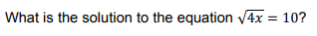
Sample Item:

As in the sample problem above, any items assessing this standard will be limited to simple, non-quadratic, rational equations. Radical equations will have real roots and solutions must be rational numbers.

Students can answer problems like the sample item above by looking for and making use of structure. For example, by recognizing that the square root of 100 is 10, students can see that what is inside the radical is equal to 100. Then the question becomes, what number multiplied by 4 will give you 100.

Solve linear equations and inequalities in one variable, including equations with coefficients represented by letters. (High Emphasis)
Students will have to solve linear equations and inequalities with one variable.

Students will also have to solve a literal equation/inequality for a specified variable. For example, Newton’s Second Law states that the force of an object is equal to its mass times its acceleration, or F = ma. But what if you had the force and the mass and wanted to figure out the acceleration? Put another way, how could you solve the formula for a? <ANSWER: a = F/m>

Students will also interpret given information to assign a value to a coefficient in a linear equation/inequality.

Sample question stem:
Given some parts of a linear equation y = mx + b, solve for any of the variables.

Sample Items:
- The equation $0.25x − 50=240$ can be used to find the total height of a ramp, in meters, given the distance, 𝑥, from the beginning of the ramp.
What is the value of 𝑥, in meters?
For students familiar with functions and especially the idea of input/output tables, many of these problems can be answered if students understand that an equation such as the one above (0.25x - 50 = 240) can be seen as a function where you are given the output (240) and asked to find the input.

- Determine the smallest integer that makes -3x + 7 -5x < 15 true.

- This sample question gives us a chance to see this type of question using an inequality instead of an equation in a context.
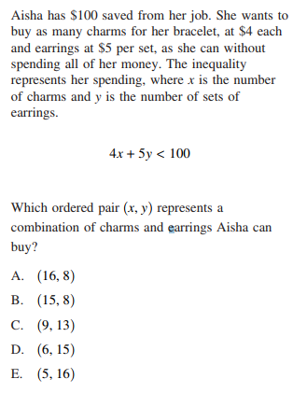

Solve quadratic equations with one variable. Use the method of completing the square to transform any quadratic equation in x into an equation of the form (x - p)² = q that has the same solutions. Derive the quadratic formula from this form. (High Emphasis)
Students will demonstrate an understanding of solving quadratic equations in one variable by completing the square.

Sample Question Stems:
Which of these quadratic equations can easily be solved by completing the square?

Sample Item:

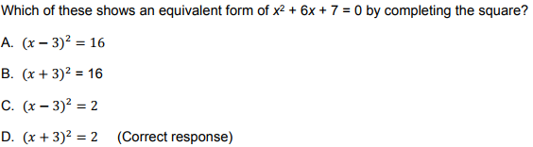

As in the sample item, quadratics will be presented in standard form (ax² + bx + c = 0).

Solve quadratic equations with one variable. Solve quadratic equations by inspection (e.g., for x² = 49), taking square roots, completing the square, using the quadratic formula, and factoring, as appropriate to the initial form of the equation. Recognize when the quadratic formula gives complex solutions and write them as a ± bi for real numbers a and b. (High Emphasis)
Students will be asked to solve quadratic equations by factoring, completing the square, using square roots, using the quadratic formula.
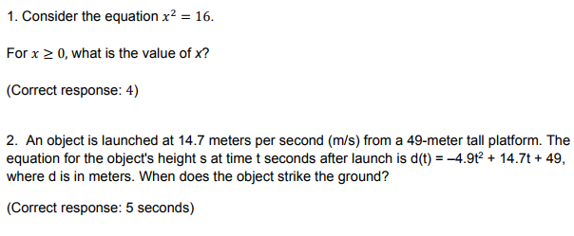
Sample Item:

Please note that the first sample item can be answered with mental math and the second can be answered using the quadratic formula, which is provided on the TASC Math Reference Sheet.

Solve systems of linear equations exactly and approximately (e.g., with graphs), focusing on pairs of linear equations in two variables. (Low Emphasis)
Students will solve systems of linear equations in two variables, using both algebraic methods and interpreting solutions with graphs. Problems assessing this standard can have a context or no context (as seen in the sample item). They will be limited to two linear equations and may or may not include a graph.

Please note that most of the problems assessing this standard can be answered by plugging the given solutions (ordered pairs) into both equations in the system. Students should also have experience looking at the graphs of two linear equations and understand the significance of where they intersect.

Sample Question Stems:
- At which point do the two linear equations intersect?
- Which values of x and y satisfy both equations?
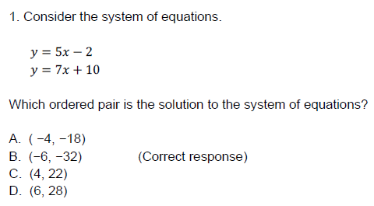
Sample Items:

2.
The graph to the left models the cost of renting video games with a membership in Plan A and Plan B.

Explain why Plan B is the better choice for Dylan if he only has $50 to spend on video games, including a membership fee.

Bobby wants to spend $65 on video games, including a membership fee. Which plan should he choose? Explain your answer.

Solve a simple system consisting of a linear equation and a quadratic equation in two variables algebraically and graphically. For example, find the points of intersection between the line y = −3x and the circle x² + y² = 3. (Medium Emphasis)
Students will solve systems of a linear equation and a quadratic equation in two variables, using both algebraic methods and interpreting solutions with graphs.

Sample Question Stem: What are the solutions for the system of y = -2x + 1 and y = x² - 2

There are no sample items provided for this standard in the TASC Item Specifications. Please note that as with the previous standard, most of the problems assessing this standard can be answered by plugging the given solutions (ordered pairs) into both equations in the system. Problems assessing this standard can have a context or no context (as seen in the sample item). They will be limited to one linear equation and one quadratic equation and may or may not include a graph.

Understand that the graph of an equation in two variables is the set of all its solutions plotted in the coordinate plane, often forming a curve (which could be a line). (High Emphasis)
Students will understand that the graph of an equation in two variables (functions) is the set of all its solutions plotted in the coordinate plane. Students will explain and verify that every point (x, y) on the graph of the equation represents values x and y that make the equation true.

Sample Question Stems:
- Which graph could represent the solution of…?
- How do the solutions of an equation relate to the graph of the equation?
- Which of the following points lie on the graph of the equation…?

Sample Item:
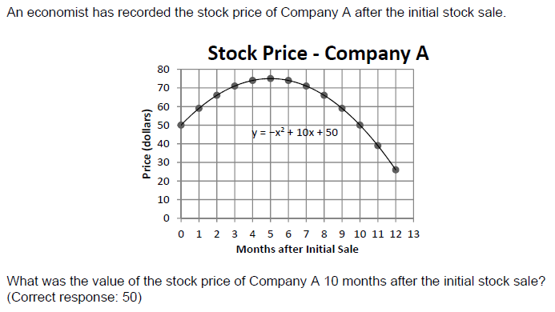

Problems assessing this standard will most likely be in a context. Answers may be numbers (as in the sample item above) but can also be graphs or explanations.

Graph the solutions to a linear inequality in two variables as a half-plane (excluding the boundary in the case of a strict inequality), and graph the solution set to a system of linear inequalities in two variables as the intersection of the corresponding half-planes. (High Emphasis)
Students will understand graphs of the solutions of a linear inequality in two variables (functions). Students will also understand graphs of the solution sets to a system of linear inequalities.

Sample Question Stems:
- Which graph shows the solution of the following inequality…?
- Which graph shows the solution to the following system of inequalities?

Sample Item:
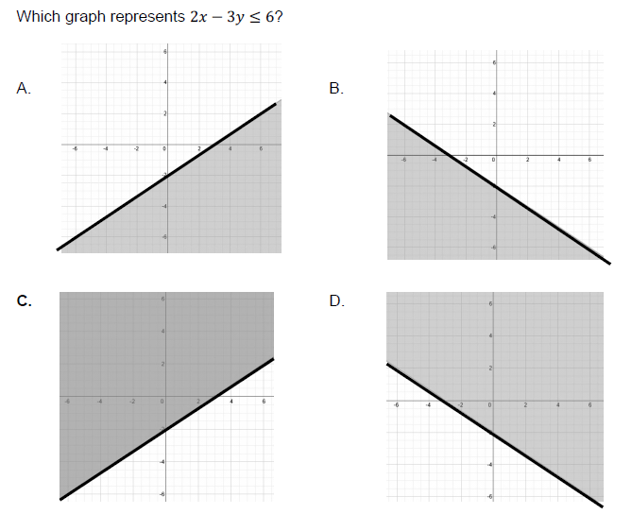
Most problems assessing this stand will have a context. Answer choices may be graphs or explanations.

CREATING EQUATIONS - 6%
Create equations and inequalities in one variable and use them to solve problems. Include equations arising from linear and quadratic functions, as well as simple rational and exponential functions. (High Emphasis)
Students will create one-variable equations (and inequalities) arising from linear, quadratic, simple rational, and exponential functions in one variable.

Sample Question Stems:
- Which equation can be used to… ?
- Which inequality can be used to determine…?

Sample Item:
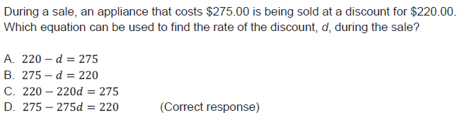

Problems assessing this standard will always provide a context. Though the standard mentions several kinds of functions, the TASC emphasizes creating linear equations. The stimulus may be a literal description of a situation, a graph, a table, or some combination of these - students should be very flexible going back and forth between these representations. The final equations (the answer choices) will have just one variable.

Create equations in two or more variables to represent relationships between quantities; graph equations on coordinate axes with labels and scales.(High Emphasis)
Students will graph equations on coordinate axes with labels and scales to represent the solution to a contextual problem. Students will create equations in two or more variables to represent relationships between quantities in a real context. Problems assessing this standard will be limited to linear equations. They will always provide students with a context and the stimulus may be a literal description of a situation, a graph, a table, or some combination of these.

Sample Question Stems:
- Which equation shows the relationship of the variables represented in the table/graph?
- Which graph represents the equation?

Sample Items:
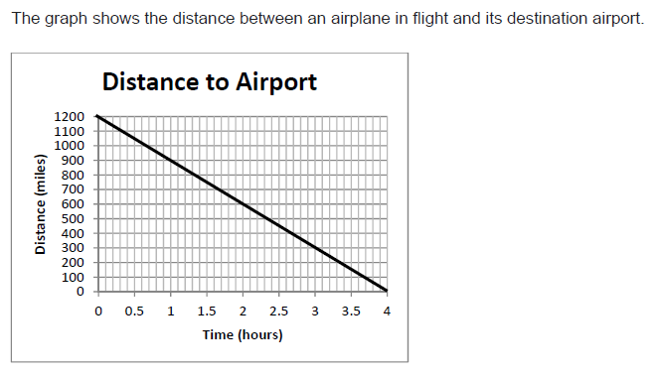

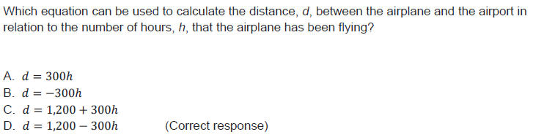

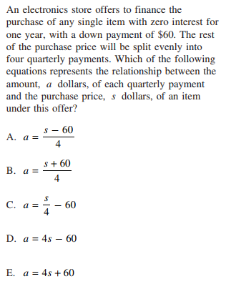

Represent constraints by equations or inequalities and by systems of equations and/or inequalities, and interpret solutions as viable or non-viable options in a modeling context. For example, represent inequalities describing nutritional and cost constraints on combinations of different foods. (High Emphasis)
Students will write and use a system of equations and/or inequalities) to solve a real-world problem. Students will recognize and explain that the equations and inequalities represent the constraints of the problem. Problems assessing this standard will be limited to linear equations. They will always provide students with a context and the stimulus may be a literal description of a situation, a graph, a table, or some combination of these.

Sample Question Stems:
- Which system of equations represents…?
- Which graph represents this situation?
- What does the solution (8,25) represent in the context of the problem?

Sample Items:
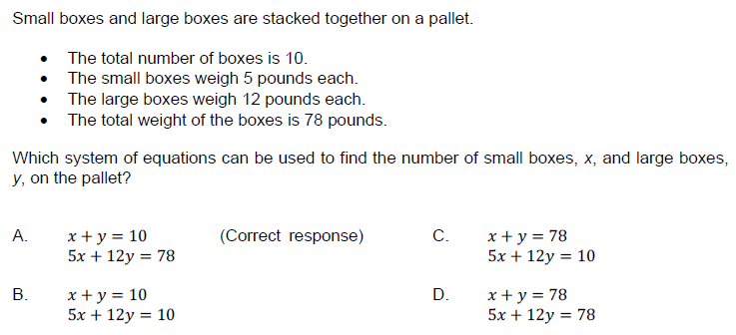
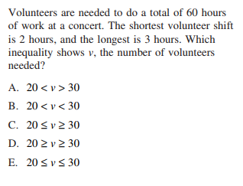

Rearrange formulas to highlight a quantity of interest, using the same reasoning as in solving equations. For example, rearrange Ohm’s law V = IR to highlight resistance R.
(Low Emphasis)
Students will solve a multi-variable equation for a given variable.

Sample Question Stems:
- Solve the equation for m.
- Rewrite the equation so that it demonstrates the hourly rate of pay.

Sample Item:
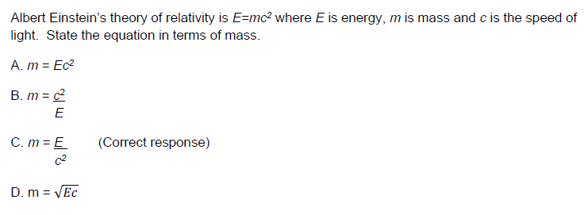

Problems that assess this standard will use either real-world formulas or a context that established the relevance of the formula. This type of problem lends itself well to using a scientific context/formula.

SEEING STRUCTURE IN EXPRESSIONS - 6%

Interpret expressions that represent a quantity in terms of its context. (High Emphasis)
Students will identify the different parts of the expression (e.g. degree, term, factor, coefficient, variable and exponent) and explain the meaning of each part of the expression within the real-world context of a problem. Students will decompose/rewrite expressions and make sense of the multiple factors and terms by explaining the meaning of the individual parts (see the second sample question stem below as an example of what this might look like)

Sample Question Stems:
- A mixture contains C liters of cleaning solution in 10 liters of water. Write an expression for the concentration of cleaning solution in the mixture, and explain what each part of the expression represents.
- A landscaping company uses two different sized trucks to deliver mulch. The first truck can transport 𝐱 cubic yards, and the second 𝐲 cubic yards. The first truck makes m trips to a job site, while the second makes n trips. a. What does x + y represent? b. What does xm + yn represent?

Sample Items:
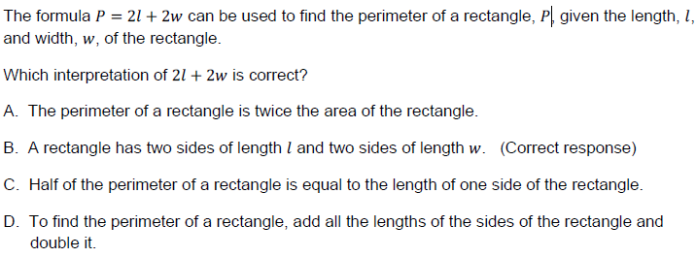

- A car leaves Albany, NY, and travels west toward Buffalo, NY.
The equation D = 280 - 59t can be used to represent the distance, D, from Buffalo after t hours. In this equation, the 59 represents the:
(1) car’s distance from Albany
(2) speed of the car
(3) distance between Buffalo and Albany
(4) number of hours driving

3. Konnor wants to burn 250 Calories while exercising for 45 minutes at the gym. On the treadmill, he can burn 6 Cal/min. On the stationary bike, he can burn 5 Cal/min. If t represents the number of minutes on the treadmill and b represents the number of minutes on the stationary bike, which expression represents the number of Calories that Konnor can burn on the stationary bike?
- b
- 5b
- 45b
- 250-5b

Choose and produce an equivalent form of an expression to reveal and explain properties of the quantity represented by the expression. (Low Emphasis)
Students will understand that the factored form of a quadratic expression reveals the zeros of the function it defines. In other words, the graph of the quadratic function in the sample item below will intercept the x-axis at (-5, 0) and (7,0). We can see that because the factored form below when x is -5 the first expression is zero and when x is 7, the second expression will be zero. Since the two expressions are being multiplied, if either of them is zero, then the output (y) would be zero. Context is not required and quadratics will all be in the form ax² + bx + c = 0, where a = 1.

Sample Question Stems:
- What is the meaning of the zeroes of a quadratic function?
- At what point(s) does the graph of the quadratic function cross the x-axis?

Sample Item:
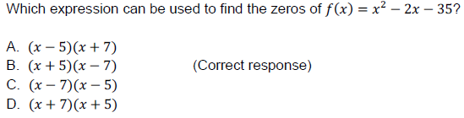

Use the structure of an expression to identify ways to rewrite it.. (Low Emphasis)
Students will use the structure of expressions to rewrite algebraic expressions in different equivalent forms by using factoring (limited), combining like terms, and using the distributive property or other operations with polynomials.

Sample Question Stems:
- Identify two expressions that are equivalent forms of the expression: h⁴ + 5h² + 4. Select two answers.
- Find a value for a, a value for b, and a value for c, so that (3x + 2)(2x − 5) = ax² + bx + c

Sample Item:
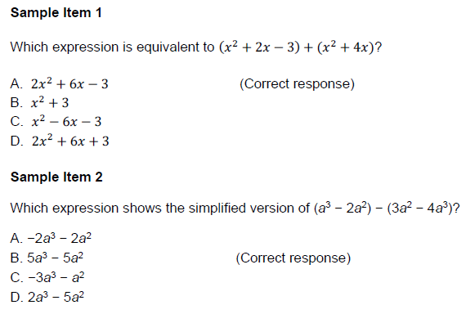
Sample Item 3
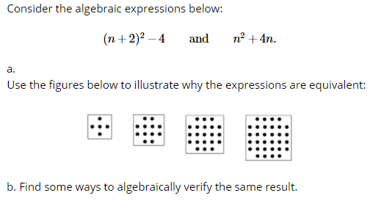

ARITHMETIC WITH POLYNOMIALS AND RATIONAL EXPRESSIONS - 6%
Understand that polynomials form a system analogous to the integers, namely, that they are closed under the operations of addition, subtraction, and multiplication; add, subtract, and multiply polynomials. (High Emphasis)
Students will

Sample Question Stems:
- Simplify (3x² + 6x) ÷ 3.
- Divide (3x² + 6x) ÷ 3x.

Sample Item:
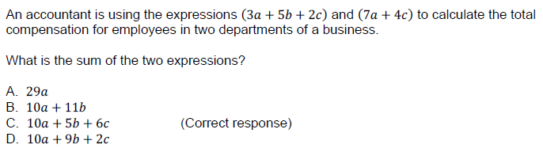

Identify zeros of polynomials when suitable factorizations are available, and use the zeros to construct a rough graph of the function defined by the polynomial. (High Emphasis)
Students will identify zeros in a polynomial. Students will also be able to sketch a graph of a polynomial, using the zeros - in other words students will understand that the zeros represent the x values when y is zero, or x-intercepts.

Sample Question Stems:
- Which equation can be used to find the zeros of…?
- What are the zeros of the function defined by the equation…?
- What are the zeros of the function shown on the graph?

Sample Items:
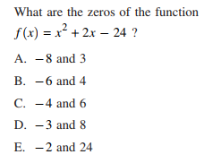

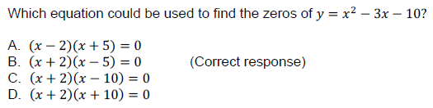

To answer the sample item above, students need to find the two values of x when y is zero. Using the factors, they can find values of x to try, so long as they recognize the number that would make each factor equal to zero. In the case of the correct response, those numbers are -2 and 5.
Problems assessing this standard will be limited to quadratics and may or may not be in a real-world context. Graphs and/or factors may be provided to help students see the zeros of a polynomial.

Additional Useful Vocabulary for Students to Know in Algebra

- Coefficient
- Equation
- Expression
- Exponent
- Factor
- Inequality
- Term
- Variable

Resources for Teaching Algebra
The CUNY HSE Math Curriculum Framework: Problem-Solving in Functions and Algebra
The framework focuses on problem-solving in functions and algebra. It integrates problem-solving strategies, productive struggle, perseverance and mathematical discussion into content learning. Includes a curriculum map, model lessons, rich engaging math problems, samples of student work, powerful routines for math classrooms, classroom videos, and more.

CUNY Framework Posts has over 50 teaching resources for teaching algebra, including lessons, problems and classroom activities. The materials are organized by the Math Algebra sub-domains:

- Reasoning with Equations and Inequalities
- Creating Equations
- Seeing Structure in Expressions
- Arithmetic with Polynomials and Rational Expressions

The sample questions are taken from the TASC Item Specifications made available by DRC/CTB, as well as items from the NYS Regents that meet the Item Specifications.
In addition to sample items, the TASC Item Specifications also sometimes include sample question stems. These are not full questions, and lack a stimuli. These stems may be used to help teachers choose and create practice problems while teaching.
According to the Examinee Guide to the Test Assessing Secondary Completion TASC Test Math Subtest and the TASC Math Item Specifications
Sample Item 3 comes from Illustrative Mathematics, which has a task for each Common Core standard.

