Closing the Gap in Science Achievement on the TASC: Focusing on Key Core Disciplinary Ideas

Life Science Standard 2 (LS2)-Ecosystems: Interactions, Energy, and Dynamics, May 18 & 19, 2015
Tom Trocco, Director of Program Support for OACE, ttrocco@schools.nyc.gov
Mary Lou Krause, Common Core Master Teacher, Central/Southern Tier RAEN
Randy Raux, Common Core Master, Teacher Central/Southern Tier RAEN

With the release of the TASC science test item analysis by McGraw Hill, we now know which Next Generation Science Indicators pose the biggest challenge for test-takers. This workshop will allow you to explore some key science standards students struggled with on previous TASC administrations as identified in the "Greatest Achievement Gap" report. You'll examine the underlying skills and concepts, strategies for teaching these concepts, and experimenting with some easy-to-reproduce hands-on activities. The content focus of today's workshop will be Life Science Standard 2 (LS2)-Ecosystems: Interactions, Energy, and Dynamics.

Learning Objectives: You will be able to:
- Understand which Indicators of the Framework of the Next Generation Science Standards represent the gap between passing and non-passing students on the TASC
- Use strategies and resources to engage students in science content in one Gap indicator: Life Science Standard 2 (LS2)-Ecosystems: Interactions, Energy, and Dynamics
- Experience some hands-on activities to support students in this indicator

Agenda Topic
- Introductions
- Objectives
- Checking in: Successes and Challenges since December
- Changes to TASC Science
- Balance
- Technology-Enhanced Items
- Discussion
- GAP Analysis
- Implications for Curriculum and Instruction
- Resources
- Next Generation Science Standards Revisited
- Organization of the NGSS
- LS 2
- Break
- Hands-on Activity: Bee Colony Collapse Disorder
(Mary Lou Krause)
LUNCH
- Hands-on Activity: Bee Colony Collapse Disorder Part 2
(Mary Lou Krause)
- Hands-on Activity 3: Oh, Deer (Carrying Capacity) (Randy Raux)
- Final Reflection
- Evaluations

Currently, 36% of the TASC Science section assesses Life Science content and practices…

TASC™ SCIENCE TEST STRUCTURE
Content Area
- Physical Sciences | 36%
- Life Sciences | 36%
- Earth and Space Sciences | 28%
- Scientific and Engineering Practices | Integrated
- Cross-Cutting Concepts | Integrated
Testing Time | 85 min  (90 min Spanish)
Number of Questions | 48/49 MC (8 stimuli)  1 Constructed Response  1 Technology-Enhanced Item

 | Disciplinary Core Ideas from the Next Generation Science Standards Assessed on the TASC™
 | Life Sciences
 | - LS1 From Molecules to Organisms: Structures and Processes
 | - LS2 Ecosystems: Interactions, Energy, and Dynamics
 | - LS3 Heredity: Inheritance and Variation of Traits
 | - LS4 Biological Evolution: Unity and Diversity
 | Earth and Space Sciences
 | - ESS1 Earth’s Place in the Universe
 | - ESS2 Earth’s Systems
 | - ESS3 Earth and Human Activity
 | Physical Sciences
 | - PS1 Matter and Its Interactions
 | - PS2 Motion and Stability: Forces and Interactions
 | - PS3 Energy
 | - PS4 Waves and Their Applications in Technologies for Information Transfer
Indicator |  | Science Items that Present the Greatest Achievement Gap Between Passing and Non-Passing TASC Test Examinees*
Earth and Space Science
ESS3-4 |  | Evaluate or refine a technological solution that reduces impacts of human activities on natural systems.
ESS3-5 |  | Analyze geoscience data and the results from global climate models to make an evidence-based forecast of the current rate of global or regional climate change and associated future impacts to Earth systems.
ESS2-1 |  | Develop a model to illustrate how Earth's internal and surface processes operate at different spatial and temporal scales to form continental and ocean-floor features.
Life Sciences
LS1-1 |  | Construct an explanation based on evidence for how the structure of DNA determines the structure of proteins which carry out the essential functions of life through systems of specialized cells.
LS2-2 |  | Use mathematical representations to support and revise explanations based on evidence about factors affecting biodiversity and populations in ecosystems of different scales.
LS2-8 |  | Evaluate the evidence for the role of group behavior on individual and species' chances to survive and reproduce.
Physical Sciences
PS4-2 |  | Evaluate questions about the advantages of using a digital transmission and storage of information.
PS2-3 |  | Apply scientific and engineering ideas to design, evaluate, and refine a device that minimizes the force on a macroscopic object during a collision.
PS1-5 |  | Apply scientific principles and evidence to provide an explanation about the effects of changing the temperature or concentration of the reacting particles on the rate at which a reaction occurs.
 |  | *from http://maxinemccormick.com/tasc/tasc-cc-achieve-9-12/

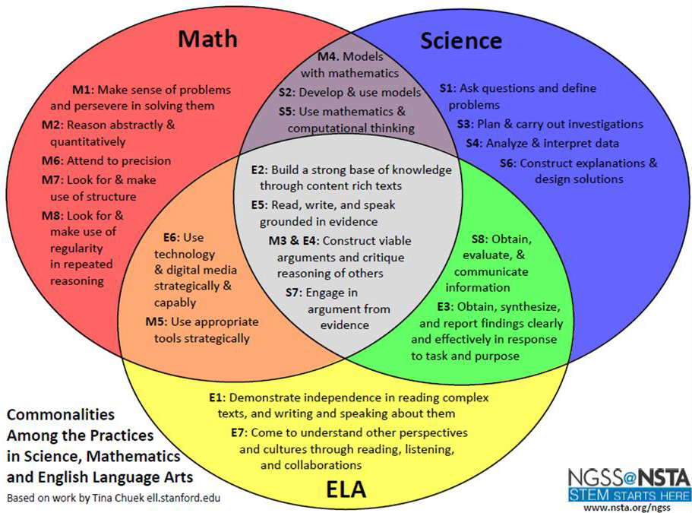

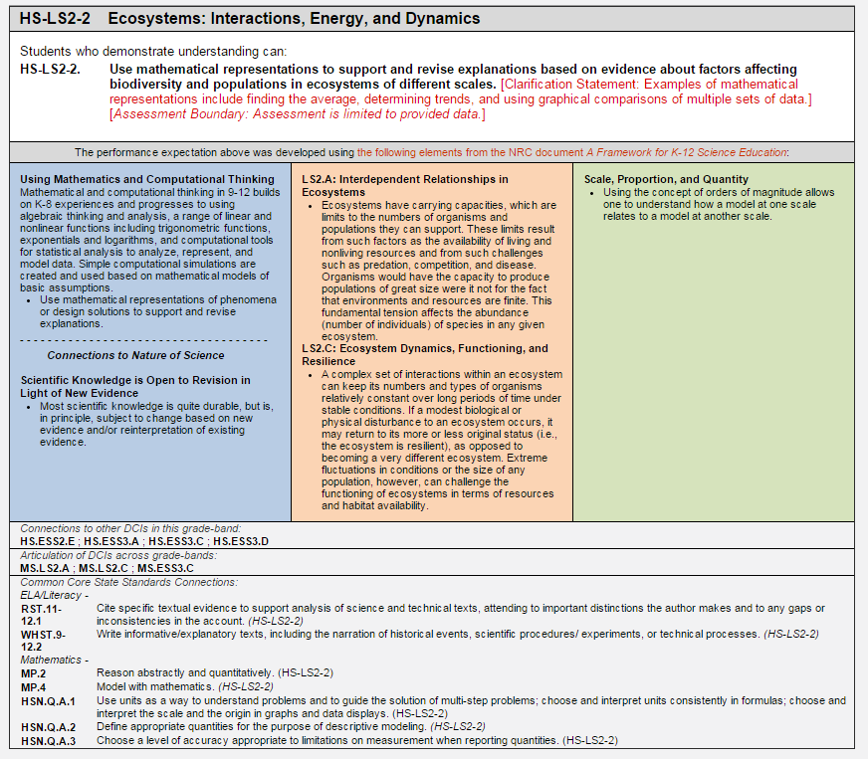
Connections Box: Connections to science standards and across grade bands, connections to Common Core Standards in Math & ELA
Foundation Box: Science & Engineering Practices, Disciplinary Core Ideas, and Cross-Cutting Concepts used to define the Performance Expectations above
Performance Expectations: what students should be able to do to show mastery
Title and Code: HS identifies this as High School, LS as Life Science

Indicator | Skill/Description | Online Resources
LS1-1 | Construct an explanation based on evidence for how the structure of DNA determines the structure of proteins which carry out the essential functions of life through systems of specialized cells. | - SS&C: 1002 Genetic Variability  - SS&C: 1003 Structural Factors in Evolution  - PBS: Nova, Genetic Variation  - PBS: Nova, Genetic Modification  - PBS: Evolution Series, Genetic Tool Kit
LS2-2 | Use mathematical representations to support and revise explanations based on evidence about factors affecting biodiversity and populations in ecosystems of different scales. | - SS&C: 904 Adaptations to Niches and Habitats  - SS&C: 955 Populations  - SS&C: 956 Limiting factors for Populations  - NGSS Classroom Activity: Bee Colony Numbers  - PBS: WGBH, Biodiversity in The Dzangha-Sangha Rain Forest  - PBS: KET, Three Levels of Biodiversity
LS2-8 | Evaluate the evidence for the role of group behavior on individual and species' chances to survive and reproduce. | - SS&C: 912 Animal Behavior  - PBS: Battle for The Elephants: Altered Elephant Behavior  - PBS: WGBH, Animal Defenses

Online Resources

Next Generation Science Standards:
- http://www.nextgenscience.org/
- http://www.nextgenscience.org/classroom-sample-assessment-tasks

PBS Learning Media
- http://ny.pbslearningmedia.org/

Scope, Sequence, and Coordination Micro-units
- http://dev.nsta.org/ssc/

CTB McGraw-Hill’s TASC™ webpage:
- http://www.tasctest.com/

Engrade TASC™ Sample Online Test Items
- https://www.engradepro.com/preview/?qk=f0da0dab1eb0a99790fe7de50058636b&section=1
Students can now experience new technology-enhanced item types before test day. The interactive demo offers practice items just like those on the new D, E and F TASC test forms. Designed to familiarize students with technology-enhanced items, this dynamic new demo will increase test taker confidence and provide examinees with a simulated online test taking experience.

Maxine McCormick’s TASC™ Common Core Achieve resources:
- http://maxinemccormick.com/tasc/tasc-cc-achieve-9-12/

Materials used in this Presentation:
- http://tinyurl.com/kxgwt58

