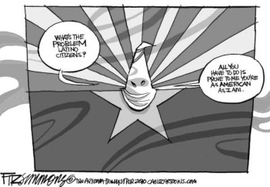
All You Have To Do Is Prove To Me You’re An American Citizen
What’s The Problem Latino Citizens?

http://www.tolerance.org/leson/editorial-cartoon-racial-profiling
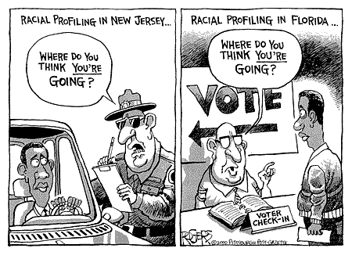

http://www.tolerance.org/lesson/editorial-cartoon-racial-profiling

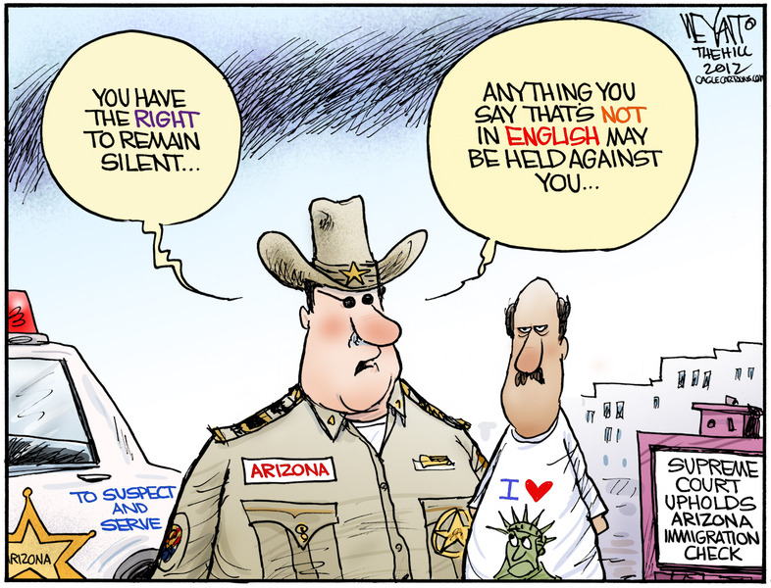

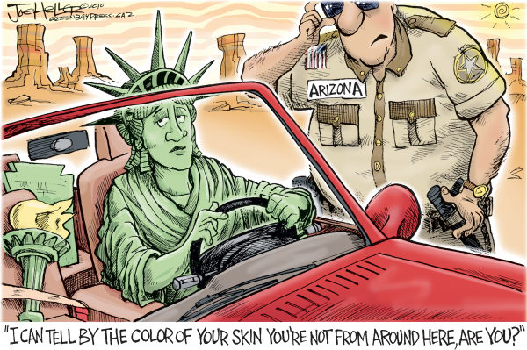

http://www.tolerance.org/lesson/editorial-cartoon-racial-profiling

http://www.tolerance.org/lesson/editorial-cartoon-racial-profiling
Arizona Legalizes Racial Profiling
Article Submitted by Sean Price on April 23, 2010
Hundreds of high school and college students gathered around the state capitol in Phoenix, Arizona, on Friday. They were there to convince Gov. Jan Brewer to veto Senate Bill 1070. These young protesters were disappointed though. Brewer signed the bill and instantly set back relations between whites and Latinos in Arizona and other parts of the country.
The law is designed to identify, prosecute and deport illegal immigrants. As outlined by The New York Times:
The police would be authorized to arrest immigrants unable to show documents allowing them to be in the country and the legislation would leave drivers open to sanctions … for knowingly transporting an illegal immigrant, even a relative. It expressly forbids cities from adopting “sanctuary” policies that restrict the police and public workers from immigration enforcement….
In other words, Arizona cops now have a green light for racial profiling—unless anyone seriously thinks that an Irish national with blonde hair and blue eyes who is in Arizona illegally will receive the same scrutiny as an Arizona-born American with darker features.
It was no accident that so many high school students protested the new law. They will be directly affected. Young people are often the chief targets of racial profiling. And this law will almost surely split up families. In many cases, young people who are U.S. citizens have one or both parents who are undocumented workers. These families already cope with enormous economic pressure. The Arizona law will almost surely ratchet up their misery. But since undocumented workers are often driven here by far greater dangers and economic pressures, the law is unlikely to do anything to slow down the flow of illegal immigration.
Opponents are lining up to attack the new law on constitutional grounds. But even if the challenges succeed, the poison has already been introduced to the state’s racial climate. Gov. Brewer argued that new methods of police training would keep police officers from abusing the law. “I will not tolerate racial discrimination or racial profiling in Arizona,” she declared. If that’s the case, she shouldn’t have signed a law that guarantees it will happen.
By the way, educators who’d like to discuss racial profiling in the classroom can use this Teaching Tolerance lesson, which defines it and explains why the subject is so important. http://www.tolerance.org/lesson/editorial-cartoon-racial-profiling

During my childhood I was aware that I was different in color from the majority of people around me, but my father and mother emphasized brainpower, not color. Color was what you were, but not using your brain was a choice.

I am struck by the different lenses through which identical events unfold and the challenges involved in unification.

Baltimore City is not unlike many inner cities throughout the country where unemployment rates for black youth tops 50 percent, and black adult unemployment hovers around 20 percent. Blight saturates neighborhood.
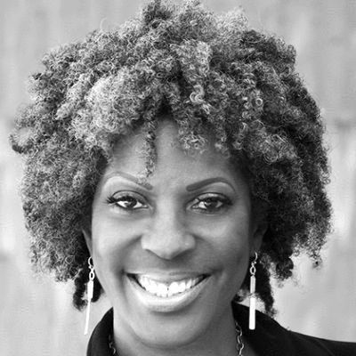

Bad police tactics can lead to bad shootings. Poor planing and a lack of communication between partner officers can lead to excessive force or even deadly force. An inability to empathize and relate to the community served can also lead to devaluation of a human life.
Isaiah Washington told HuffPost Live on Thursday that he was "racially profiled in Silicon Valley" on Saturday, April 18. Washington explained to H...

Arizona Sheriff Joe Arpaio dropped a bombshell in court Thursday when he said his former lawyer had hired a private investigator to look into the wife...

A broken taillight can also be a life-altering offense for some brown-skinned motorists. Among immigrants, fear persists that a minor traffic violation could lead to deportation and the splintering of family.

While it may not have been Tammy's intent, posing this seemingly innocuous question is a poorly disguised micro-aggression that perpetuates the belief that Asian-Americans are cultural and racial outsider within the American context. T

http://politicalhumor.about.com/od/immigration/ig/Immigration-Cartoons/Arizona-and-Racial-Profiling.htm

