Sheriff’s posse goes on school patrol
By Roseanne Pereira Grade Level 4 01.25.13 Word Count 712
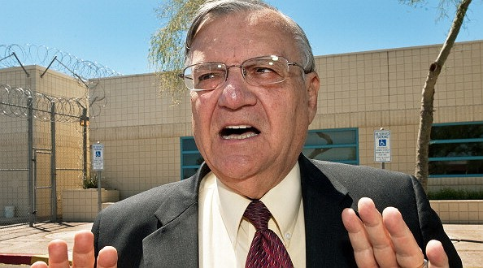

Maricopa County Sheriff Joe Arpaio speaks with a reporter outside the city jail in this May 3, 2010, file photo. Photo: AFP/Getty Images

Joe Arpaio is a county sheriff in Arizona. He calls himself “the toughest sheriff in America.” Many people like him because he is tough on criminals. He makes jail inmates wear pink underwear. He doesn’t allow them to have salt and pepper with their meals. Other people hate the sheriff. They think he treats minorities unfairly.

Posse On Patrol
Sheriff Arpaio is famous for his “posse.” They are a group of volunteers who help the sheriff. Arpaio first formed the group in 1993. Back then, there was a problem with shopping mall thefts. The posse did patrols of the malls during the holidays.
Later, the posse became known for helping the sheriff with immigration raids. The sheriff did the raids to find and arrest foreigners. They were arrested because they don’t have the proper documents to work in the United States.
In December there was a tragic school shooting in Connecticut. Sheriff Arpaio turned his attention to school safety. He decided to give his posse a new task. They will patrol 59 schools in the county.

Who’s In The Posse?
The sheriff’s posse volunteers drive around and near school grounds. They look for suspicious activity. They are not inside the schools or on school property. They are in cars that look just like the sheriff’s deputies’ cars. They also wear uniforms that they pay for themselves.
Posse members do not get paid for working. They receive basic training from the sheriff’s department. Some of the volunteers carry weapons with them while they are on patrol.
Sheriff Arpaio talked about his plan on some national television news programs. School officials were not asked ahead of time if they wanted the help from volunteers. Neither were parents. Some found out about the plan from watching the national news.
The sheriff’s plan has critics. They wonder if it is safe to trust the volunteers. The posse includes retired police officers. It also includes some men who have served in the military. A local TV news investigation found out more about the volunteers. It uncovered that some have criminal records, including violent crimes. The sheriff says that he has faith in the posse.

Who’s In The Posse?
The sheriff’s posse volunteers drive around and near school grounds. They look for suspicious activity. They are not inside the schools or on school property. They are in cars that look just like the sheriff’s deputies’ cars. They also wear uniforms that they pay for themselves.
Posse members do not get paid for working. They receive basic training from the sheriff’s department. Some of the volunteers carry weapons with them while they are on patrol.
Sheriff Arpaio talked about his plan on some national television news programs. School officials were not asked ahead of time if they wanted the help from volunteers. Neither were parents. Some found out about the plan from watching the national news.…..etc

Possible writing activity
Write a short paragraph that explains the central idea of the article. Use at least two details from the article to support your response.
https://newsela.com/articles/arizona-posse/id/41/write/

