

197 Franklin Street • Auburn, NY 13021 • 315.255.1743 x2150

Navigate via the internet to Google Apps for Education - http://www.google.com/enterprise/apps/education/

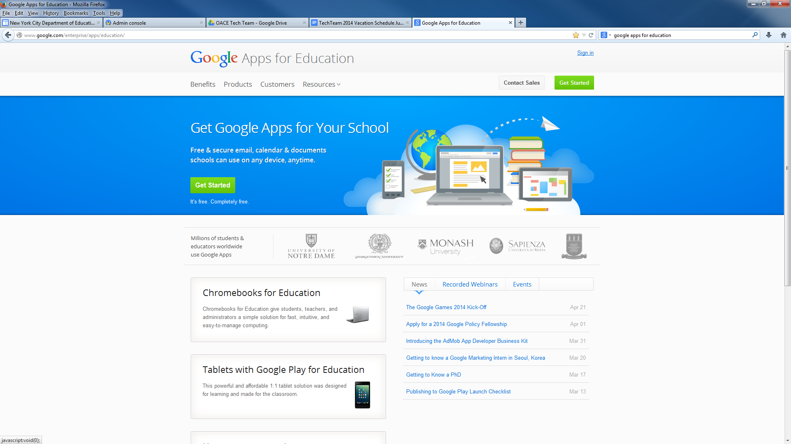
Fig. 1

Select the “Get started” link circled in red above. Then see Fig. 2 below.
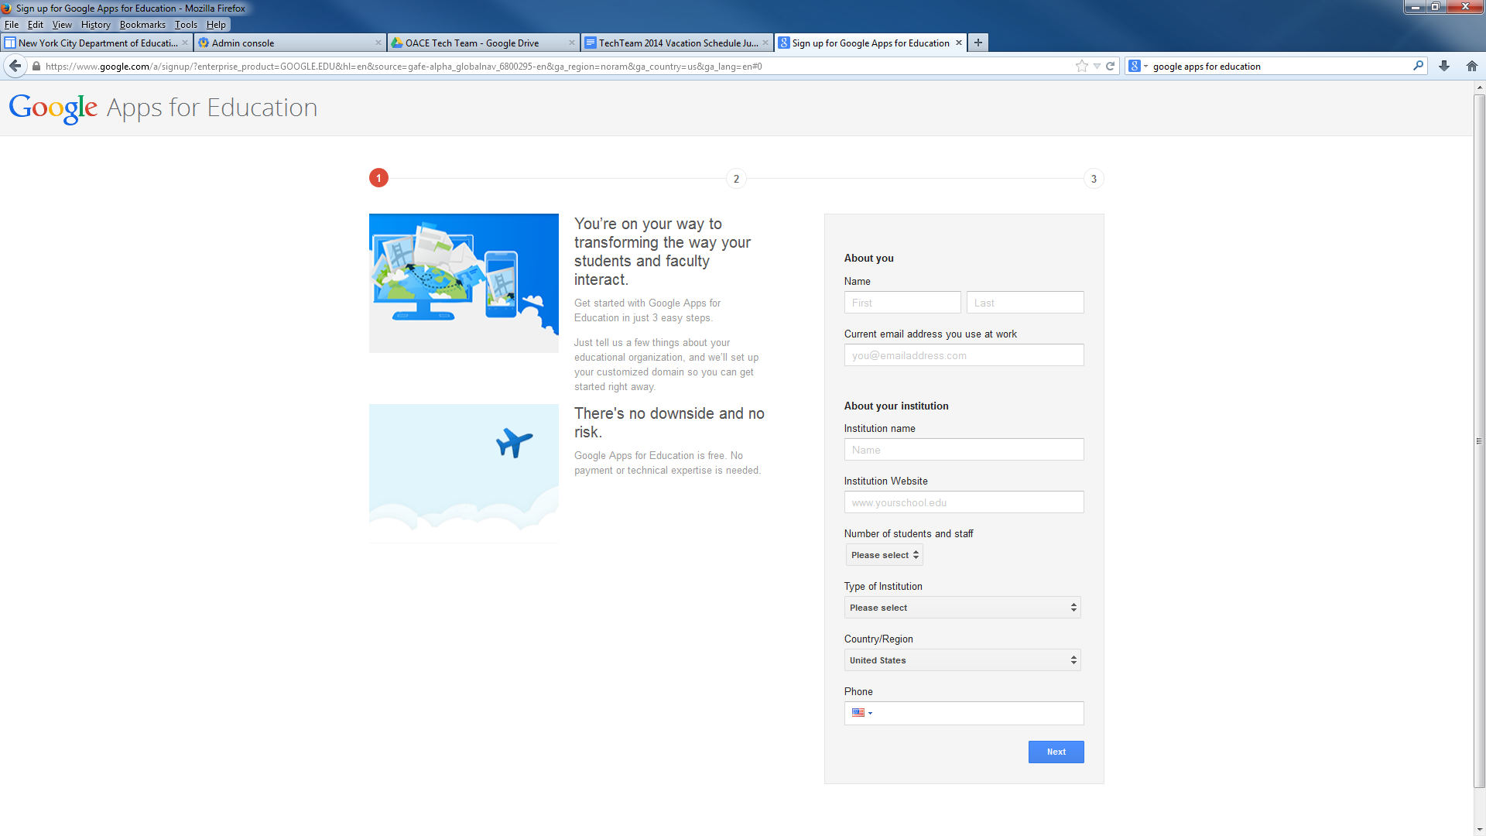
Fig. 2

Complete the Bio information. If you do not have a website, leave that space empty.

Select a domain name. Be careful with the domain name that you select as this would reflect the email extensions for your users. Our NYC domain name is: oacenyc.org. Select inside the blue rectangle to change to .com, .org, or .net. Fill out the “Your address” section with the school address. Click the “Check Availability” button to indicate if the domain name is available. Then select “next” at the button.

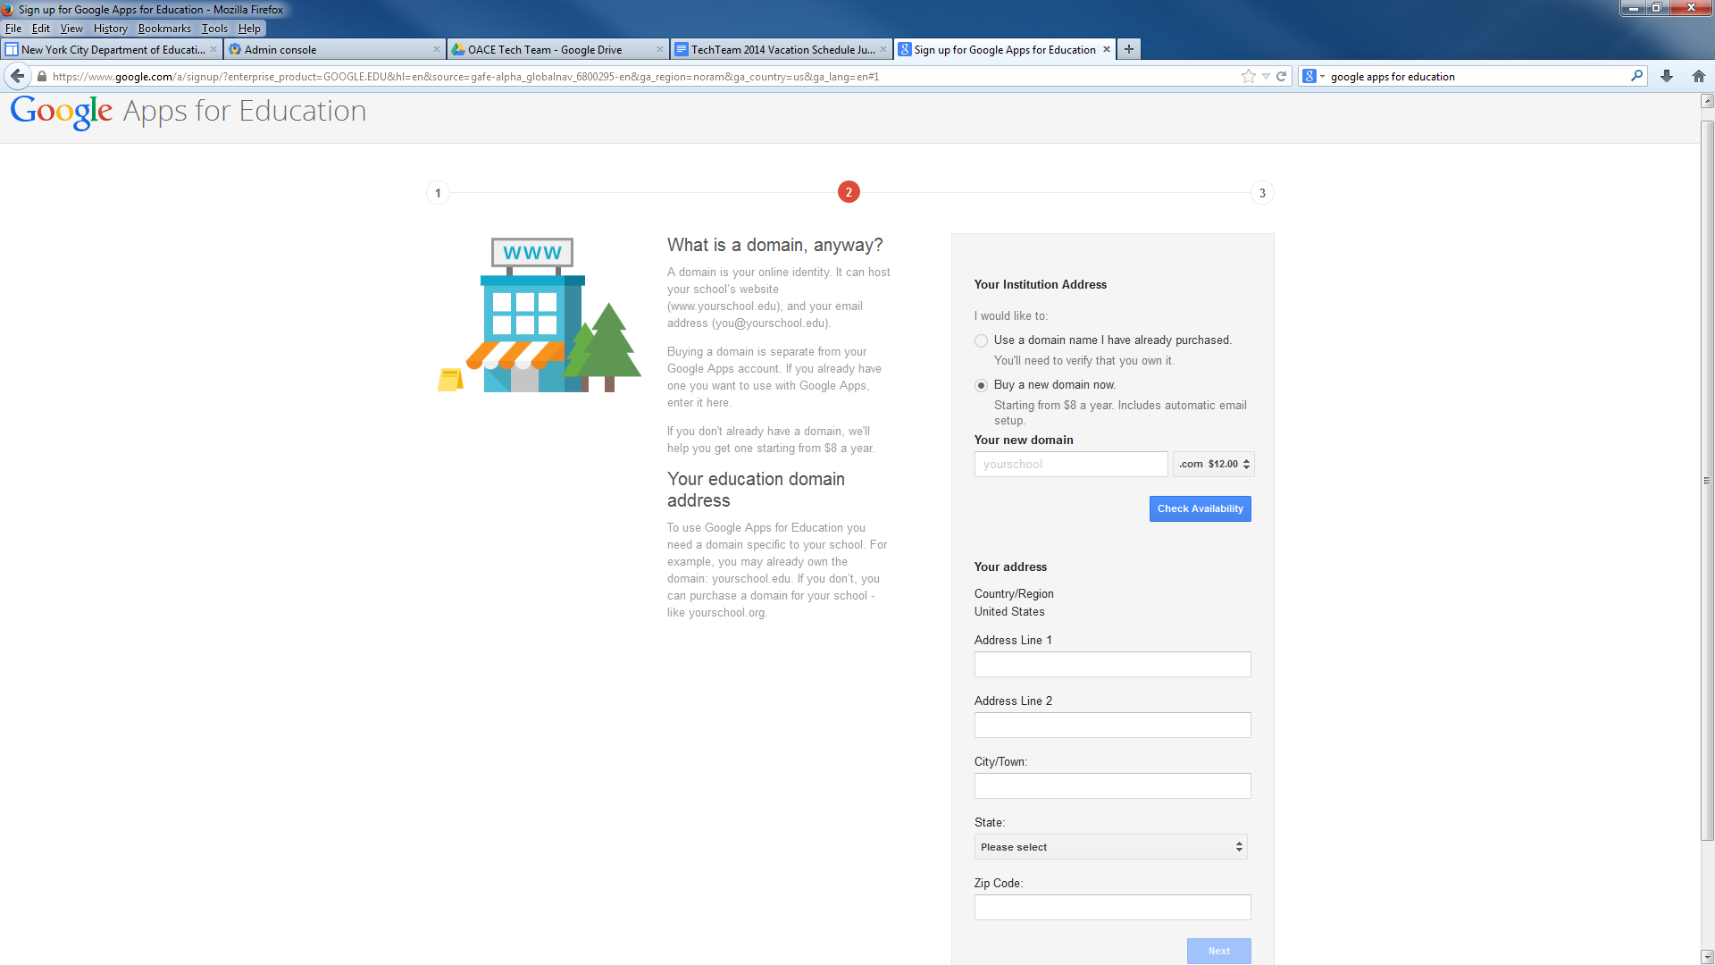
Fig. 3

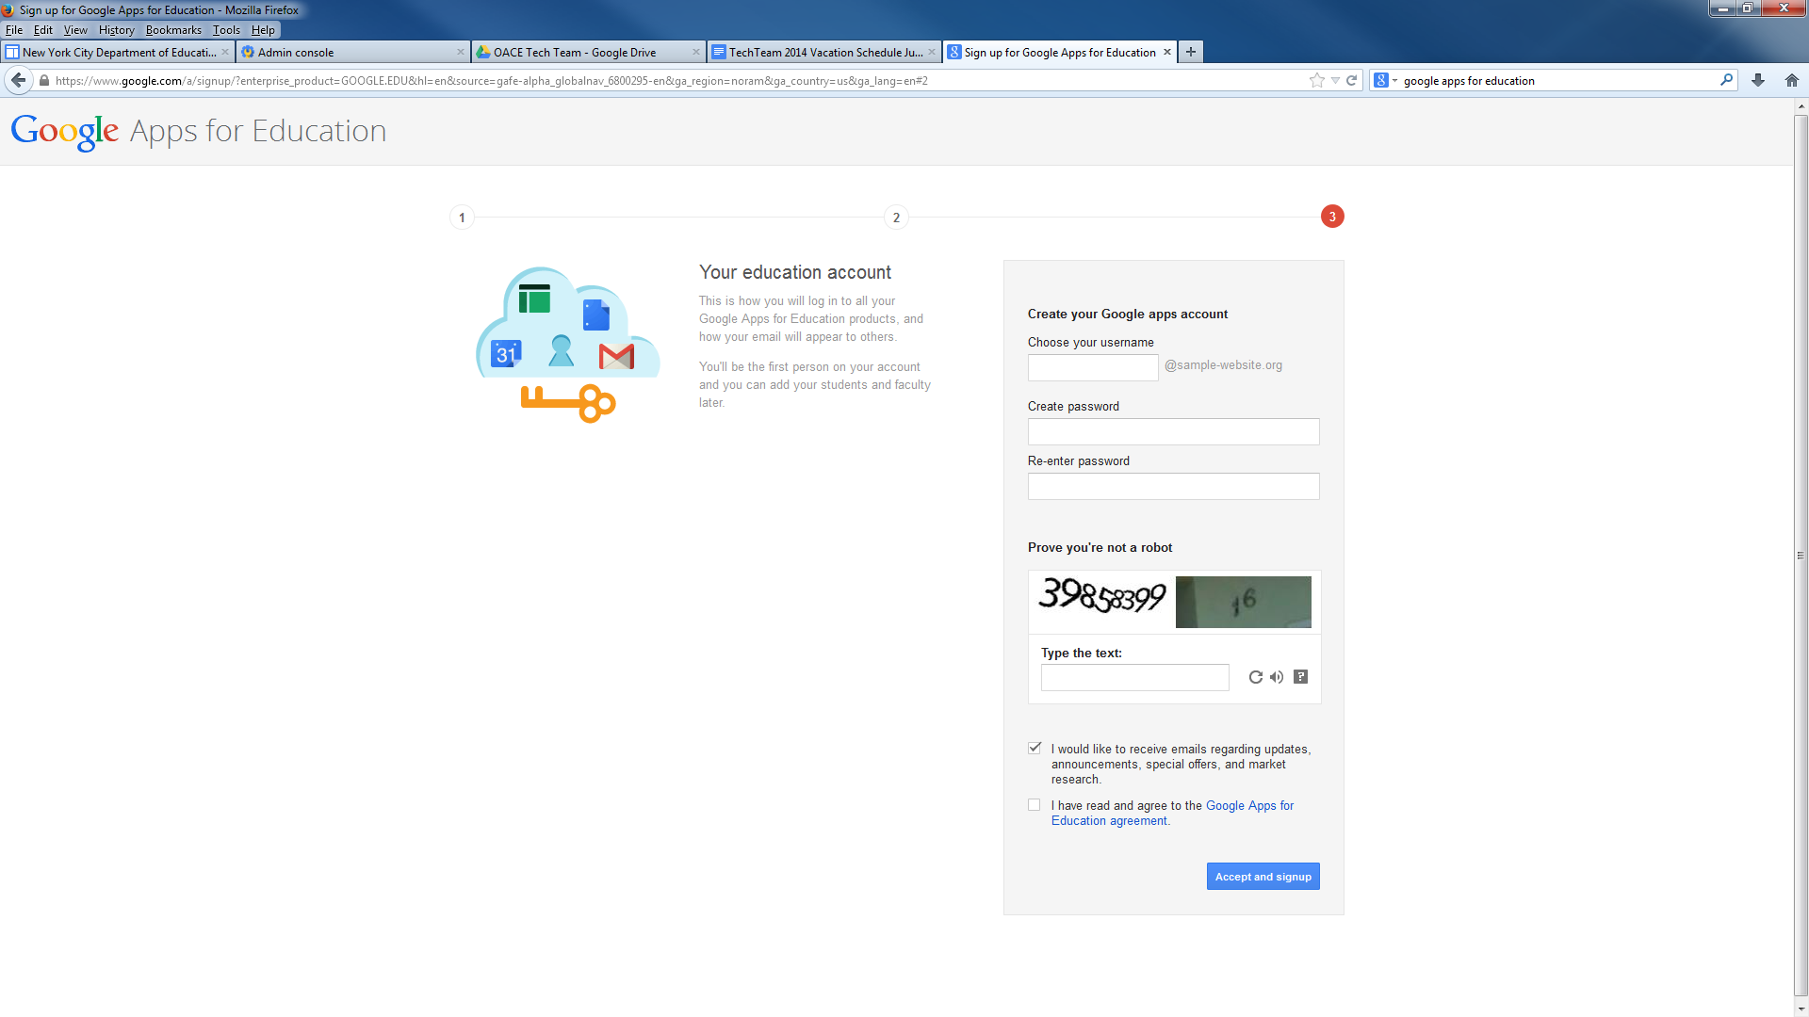
Choose your username. This will be your username as the “Super Administrator” for the portal. Choose carefully. Create and re-enter a password. Check the “Google Apps for Education Agreement” checkbox. Then, select accept and signup.

Select “Purchase your new domain”

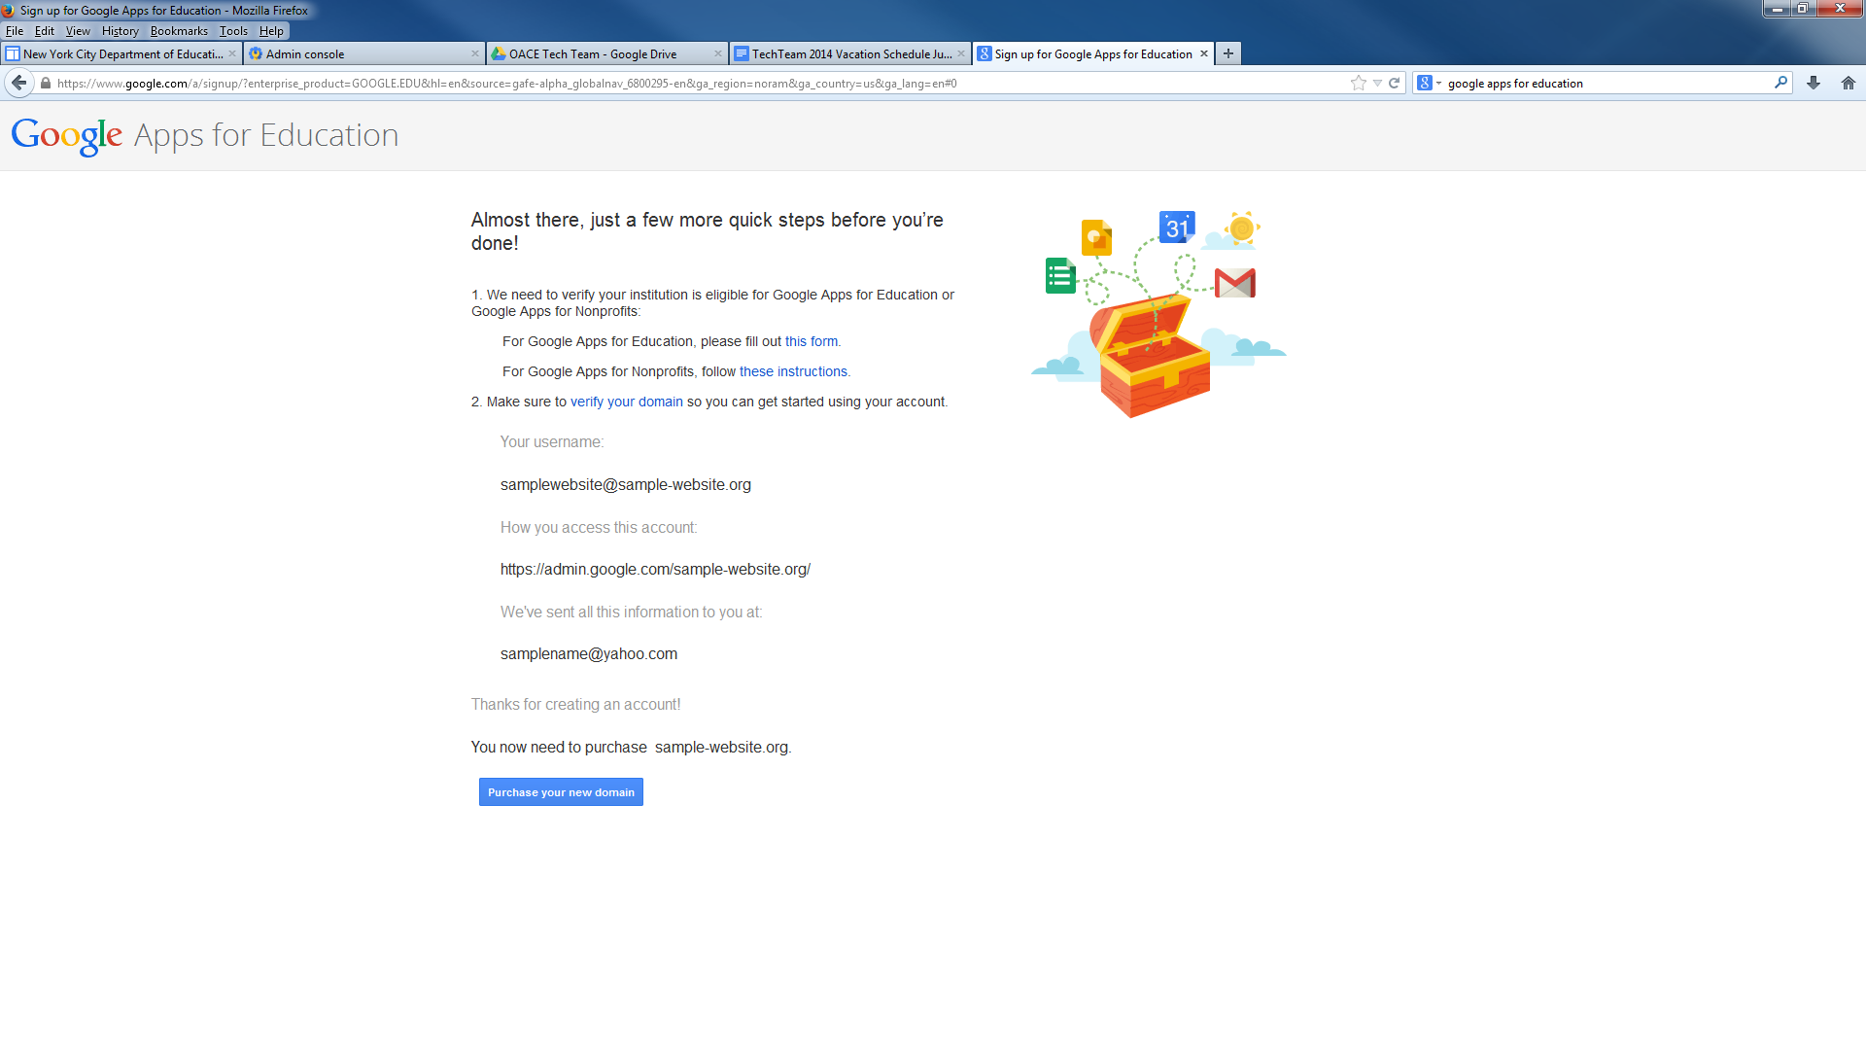

Please have your organizations credit card and be prepared to pay $12.00 for the domain name. This is an annual recurring cost.

