McDonald's announces new ways to help its workers
By Chicago Tribune, adapted by Newsela staff Grade Level 4 04.07.15
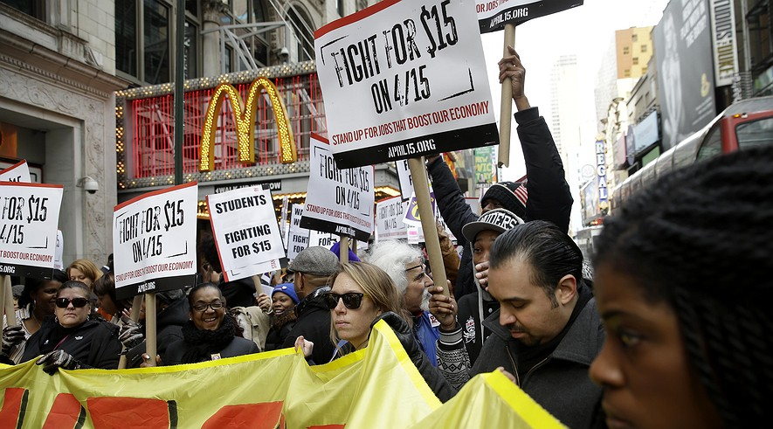

People participate in a rally for a $15-an-hour wage in front of a McDonald's in New York City in March 2015. The fast-food firm announced it is raising wages at company-owned stores by $1 an hour, effective July 1. Photo: AP Photo/Seth Wenig
CHICAGO — For months, McDonald's workers have been getting together and protesting. They are asking for higher pay. Now, McDonald's is making changes. This week, the company announced three new ways it would help its workers.

First, it will pay workers $1 more per hour. It will also give them paid vacation time. Finally, McDonald's will help workers get an education.

Steve Easterbrook became the head of McDonald's a month ago. He wants to make McDonald's more modern and forward-looking.

In the past, McDonald's had a bad reputation. Newspapers wrote about the company not treating its workers well. Fewer people wanted to eat at McDonald's. Easterbrook hopes to help change that.

Starting in July, average hourly rates will rise from $9 to $10 an hour.

Company To Also Offer Vacation Pay, Education Benefits
The company also announced plans to give paid personal time off to long-term employees. If workers do not take this time off, they will be paid for the value of that time.

“We understand that life balance is important and believe that this will make a difference for our people,” Easterbrook said.

McDonald’s is also helping its workers get an education. The company will pay for employees to finish high school or take college classes.
Still, there are problems. Workers say the $1 raise is not enough.

Not All McDonald's Workers Will Get The Raise
Worker-groups want a $15-per-hour wage. They say they cannot survive on any pay less than that, even if they work a full 40 hours per week.

On top of that, not all of them will get the raise. There are about 750,000 McDonald’s workers in the United States. Only about 90,000 of them will get the $1 raise. Those workers are at locations owned by McDonald’s itself.

Most McDonald’s locations are owned by someone who has a deal with the company. These owners make their own decisions about pay in their stores.

Today, the U.S. minimum wage is $7.25; that is the lowest amount of money per hour that businesses are allowed to pay people. Some cities and states have set their own minimum wages that are higher.

For workers who have been fighting for a living wage, the $1 increase is a small step in the right direction. The battle is not over, though.

Workers Say Campaign Will Continue
Protests and strikes will continue “until workers get what they’ve been fighting for,” said Kendall Fells. He is a director of the Fight for 15 campaign.

Workers protested in front of McDonald’s stores across the country on April 2. They are planning to protest again on April 15.

Fells said that by organizing and protesting, workers have forced McDonald’s to make changes. The changes, however, have been small so far.

He talked about the next steps. He said workers should group together. Then a leader can talk directly to McDonald's about wages and benefits.

Nancy Salgado is a McDonald’s worker at a restaurant in Chicago. She said the new changes are a win for the Fight for 15 group. Still, they won’t help her or thousands of other workers.

