What is a Concept Map?

A concept map is a type of [**graphic organizer**](http://www.inspiration.com/inspiration-socialstudies-examples) used to help students organize and represent knowledge of a subject. Concept maps begin with a main idea (or concept) and then branch out to show how that main idea can be broken down into specific topics.

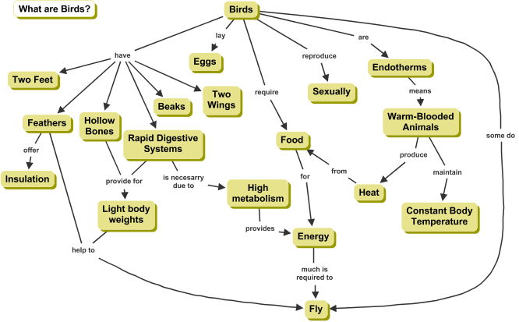

<http://cmap.ihmc.us/docs/Concept.php>

## Benefits of Concept Mapping

Concept mapping serves several purposes for learners:

* Helping students brainstorm and generate new ideas
* Encouraging students to discover new concepts and the propositions that connect them
* Allowing students to more clearly communicate ideas, thoughts and information
* Helping students integrate new concepts with older concepts
* Enabling students to gain enhanced knowledge of any topic and evaluate the information

## How to Build a Concept Map

Concept maps are typically hierarchical, with the subordinate concepts stemming from the main concept or idea. This type of graphic organizer however, always allows change and new concepts to be added. The Rubber Sheet Analogy states that concept positions on a map can continuously change, while always maintaining the same relationship with the other ideas on the map.

Start with a Main Idea, Topic or Issue to Focus on.

A helpful way to determine the context of your concept map is to choose a focus question—something that needs to be solved or a conclusion that needs to be reached. Once a topic or question is decided on, that will help with the hierarchical structure of the concept map.

Then Determine the Key Concepts

Find the key concepts that connect and relate to your main idea and rank them; most general, inclusive concepts come first, then link to smaller, more specific concepts

Finish by Connecting Concepts---creating linking phrases and words

Once the basic links between the concepts are created, add cross-links, which connect concepts in different areas of the map, to further illustrate the relationships and strengthen student’s understanding and knowledge on the topic.

<http://www.inspiration.com/visual-learning/concept-mapping>