Inscribed Angles in Circles
What if your family went to Washington DC over the summer and saw the White House? The closest you can get to the White House are the walking trails on the far right. You got as close as you could (on the trail) to the fence to take a picture (you were not allowed to walk on the grass). Where else could you have taken your picture from to get the same frame of the White House? Where do you think the best place to stand would be? Your line of sight in the camera is marked in the picture as the grey lines. The white dotted arcs do not actually exist, but were added to help with this problem.
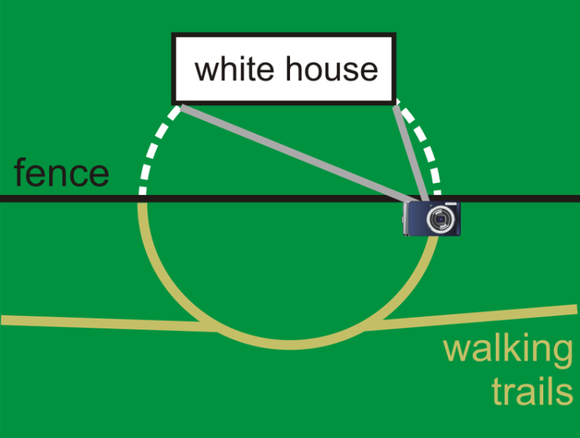

Do Now:
Draw a circle and label all the different parts of a circle that you know. Afterwards, define those parts.

Investigation: Measuring an Inscribed Angle Name:___________________________
1. Draw three circles with three different inscribed angles. For , make one side of the inscribed angle a diameter, for , make inside the angle and for make outside the angle. Try to make all the angles different sizes.

2. Using your ruler, draw in the corresponding central angle for each angle and label each set of endpoints.

3. Using your protractor measure the six angles and determine if there is a relationship between the central angle, the inscribed angle, and the intercepted arc.

What conclusions can you make regarding the relationship between the central angle, the inscribed angle, and the intercepted arc?

Name:___________________
Example A: Find and .
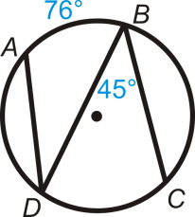

Example B: Find and .
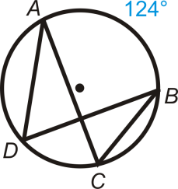

Example C: Find in .
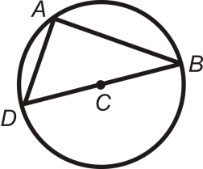

More Guided Practice
1. Find and .
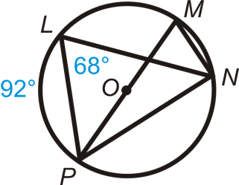
Find the value of and/or in .
2.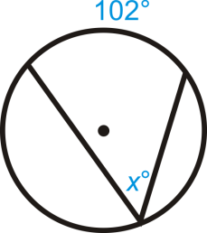
3.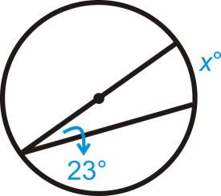
4.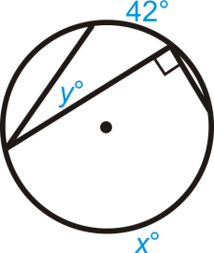
- 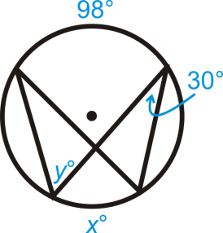
- 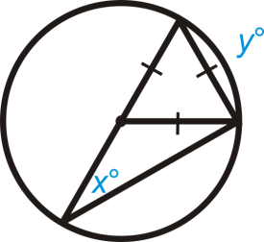
Solve for .
7.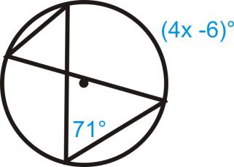

8.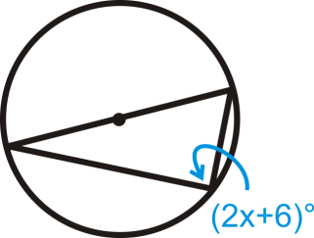

9.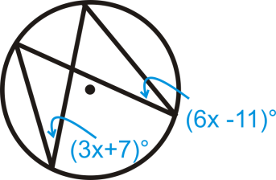

- 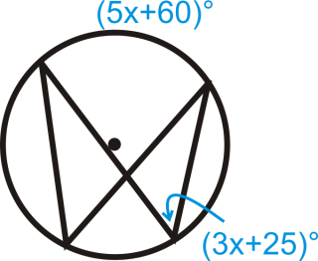

Name:_______________________ Syracuse Fall ‘14
1. True or False: An inscribed angle is an angle with its vertex on the circle and whose sides are chords.

2. True or False: The intercepted arc is the arc that is inside the inscribed angle and whose endpoints are on the angle.

3. In the given figure what is the measure of arc BC.
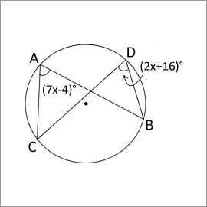
A) 24 degrees
B) 48 degrees
C) 90 degrees
D) none of the above

4. Anytime a right angle is inscribed in a circle, the endpoints of the angle are the endpoints of a diameter and the diameter is the hypotenuse.

5. Given that line segment BD is a diameter of the circle, what must be true about arc CD? 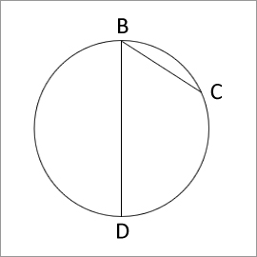
A) It is exactly 90 degrees
B) It is exactly 180 degrees
C) It is between 0 and 180 degrees
D) It is between 180 and 360 degrees

6. In the given figure find the measure of the angle ADB.
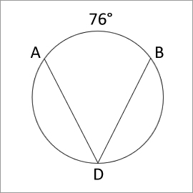
A) 38 degrees
B) 76 degrees
C) 114 degrees
D) none of the above

7. True or False: Angle ACB is the inscribed angle.
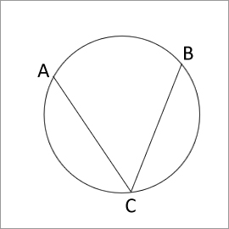

8. Find the measure of angle ACD in the given figure.
A) 67 degrees
B) 42.8 degrees
C) 33.5 degrees
D) 20 degrees

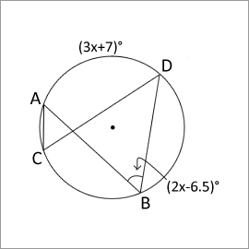

9. True or False: Inscribed angles that intercept the same arc are non-congruent.

10. An angle inscribed in a major segment is always _____.
a) Acute b) Obtuse c) Right angle d) Supplementary angle
11. True or False: The vertex of an inscribed angle can be outside the circle as long as its sides intersect the circle to form an intercepted arc.

12. True or False: In the given figure x=85 .
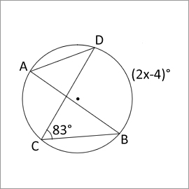

13. In the given figure find the measure of angle ADB.
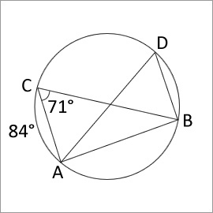
A) 28 degrees
B) 142 degrees
C) 48 degrees
D) 71 degrees

14. In the given figure find the measure of angle ADB.
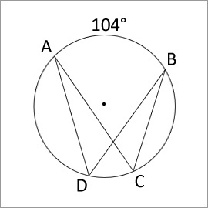
A) 104 degrees
B) 52 degrees
C) 208 degrees
D) 90 degrees

15. True or False: In the given figure the measure of angle PRQ is 45 degrees.
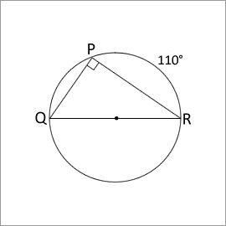

16. Find the value of 'x' in the given figure.
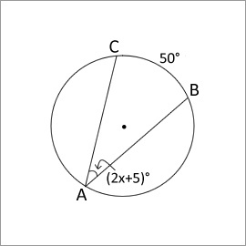

An inscribed angle is an angle with its vertex on the circle and whose sides are chords. The intercepted arc is the arc that is inside the inscribed angle and whose endpoints are on the angle. The vertex of an inscribed angle can be anywhere on the circle as long as its sides intersect the circle to form an intercepted arc.
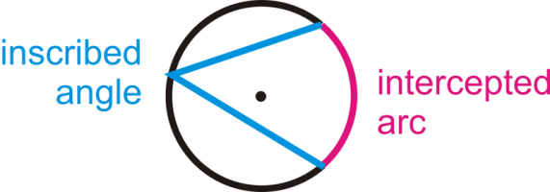
The Inscribed Angle Theorem states that the measure of an inscribed angle is half the measure of its intercepted arc.
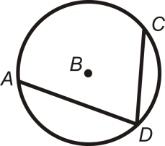
Inscribed angles that intercept the same arc are congruent. This is called the Congruent Inscribed Angles Theorem and is shown below.
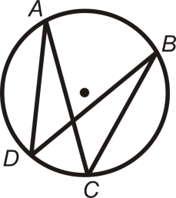
and intercept , so . Similarly, and intercept , so .
An angle intercepts a semicircle if and only if it is a right angle ( Semicircle Theorem ). Anytime a right angle is inscribed in a circle, the endpoints of the angle are the endpoints of a diameter and the diameter is the hypotenuse.
intercepts a semicircle, so . is a right angle, so is a semicircle.
An angle intercepts a semicircle if and only if it is a right angle ( Semicircle Theorem ). Anytime a right angle is inscribed in a circle, the endpoints of the angle are the endpoints of a diameter and the diameter is the hypotenuse.
