List the objects or people you see I the cartoon | List the objects that are symbols | List what you think each Symbol means
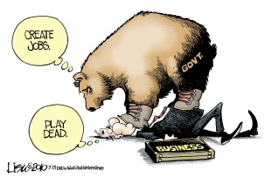
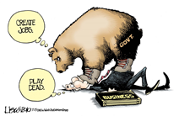
Political Cartoon Analysis Worksheet

What’s the message?

If you were asked to explain the message you identified, what would your explanation be? Why?

