Title:

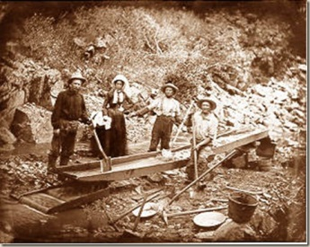

1 | In 1865, just after the American Civil War, a $100,000 gold shipment
 | disappeared in Georgia. Thieves stole two wagon trains filled with
 | gold France had loaned the money to the South. The gold was on its
 | way to back Franc. While soldiers were waiting for their orders, the
5 | gold disappeared. No one knows what happened to the gold. Some say
 | the gold was divided among local people. Others say it was buried in a
 | nearby river. Some say it was buried on a local plantation. Soldiers
 | questioned the local people. But the gold was never found. No one was
 | ever seen spending any gold coins. After heavy rainstorms, however,
10 | gold coins were often found on dirt roads near the plantation. Some
 | people believe that the treasure is hidden somewhere near the
 | plantation. People still search. No one has found the gold yet.

Excerpt taken from: D Anthology 1. Passageways Series By: Curriculum Associate

