









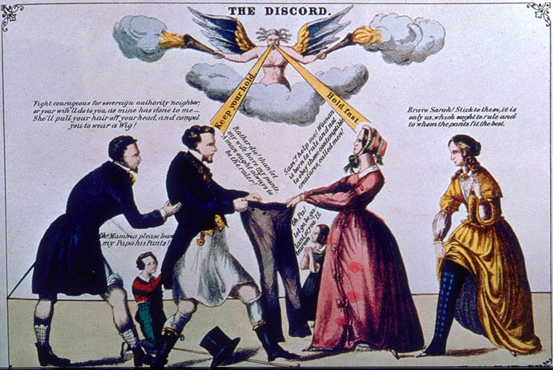

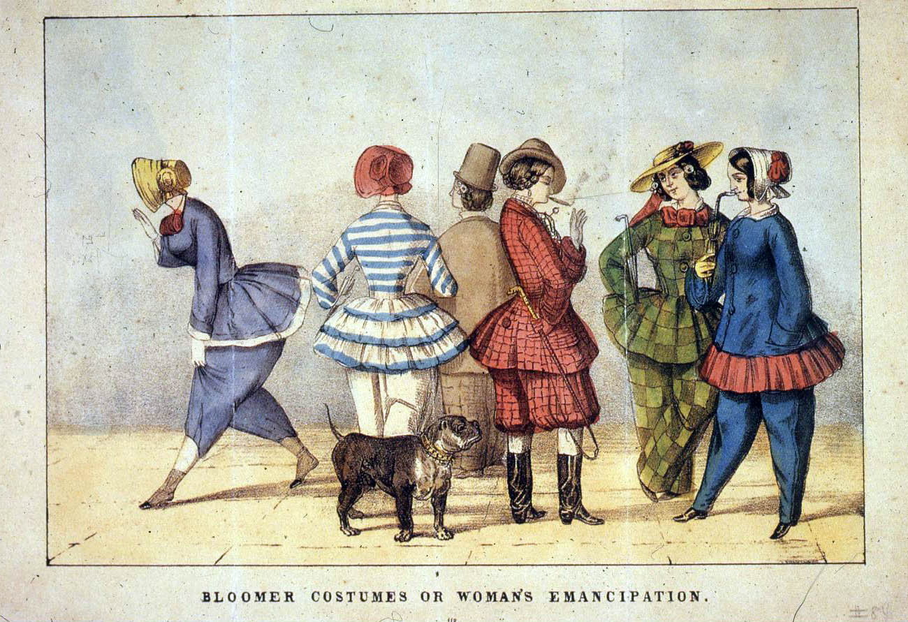













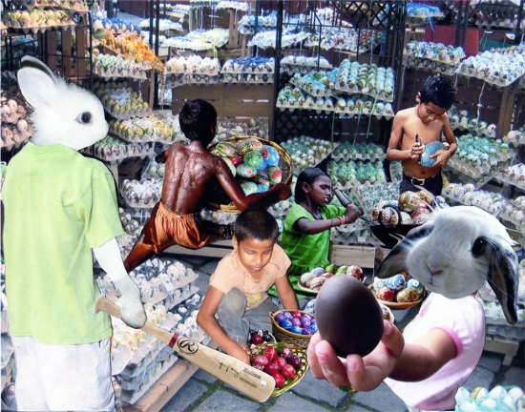

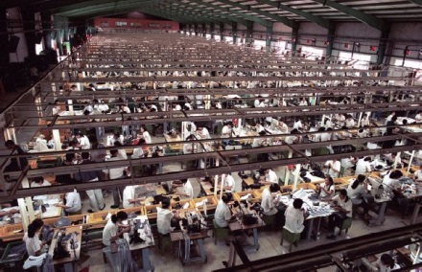







[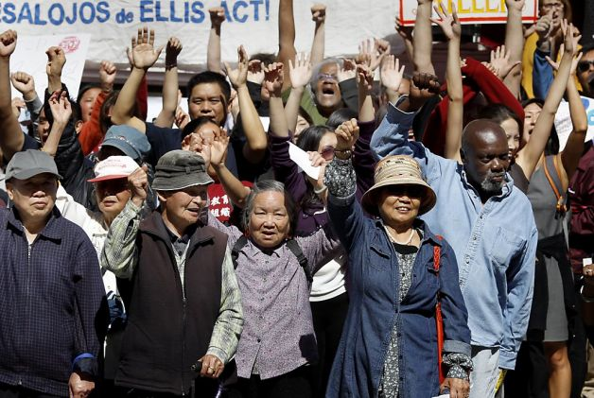](http://www.google.com/url?sa=i&rct=j&q=housing%20rights%20movement&source=images&cd=&cad=rja&uact=8&docid=uf68sEGI752qWM&tbnid=He3O81f22ghf4M:&ved=0CAUQjRw&url=http://www.popularresistance.org/elderly-familys-eviction-fuels-growing-san-francisco-housing-rights-movement/&ei=hpw9U_6jDerLsQSjooDwDQ&psig=AFQjCNHyNBHL3FIircka1ZnKBw51H6UoPg&ust=1396632914505320)

[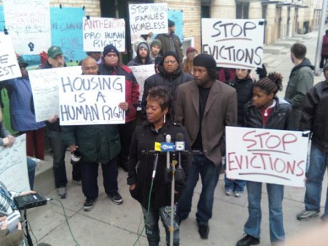](http://www.google.com/url?sa=i&rct=j&q=housing%20rights%20movement&source=images&cd=&cad=rja&uact=8&docid=1qBHc6WjHdworM&tbnid=bPIVp66_sh5k9M:&ved=0CAUQjRw&url=http://talktostambrose.wordpress.com/tag/housing-rights-movement/&ei=w5w9U8GoNIjJsQTfhIH4BQ&psig=AFQjCNHyNBHL3FIircka1ZnKBw51H6UoPg&ust=1396632914505320)