From a square sheet of paper 20 cm by 20 cm, we can make a box without a lid.
We do this by cutting a square from each corner and folding up the flaps.
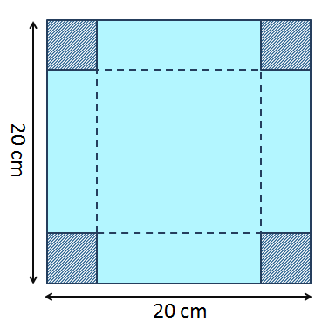
Investigate what volumes are possible for different sizes of cut-out squares.
1) Will you get the same volume irrespective of the size of the squares that are cut out?
2) What is the maximum possible volume and what size cut produces it?
3) Can you find a relationship between the size of paper and the size of cut that produces the maximum volume?

