ELA College and Career Readiness Standards addressed:
- Reading 1, 2, 3, 5, 7, 10, 11
- Writing 1, 2, 3, 4, 5, 7, 8, 9, 10, 11
- Speaking and Listening 1, 2, 4, 6
- Language 1, 2, 3, 4, 5, 6
- RST 1, 2, 4, 5, 6, 7, 8, 9
- WHST 1, 4, 5, 6, 7, 9
- Next Generation Science Standards addressed: HS-LS2 6

Objectives:
- Students understand the importance of mutual relationships in ecosystems.
- Students use guided questions to investigate Colony Collapse Disorder.
- Students summarize the issues associated with Colony Collapse Disorder.
- Students evaluate a speaker’s point of view, reasoning, and use of evidence and rhetoric.

Materials:
- Lesson 1 Quiz – copies for each student
- Handout – Honey bees are dying at alarming rates.
- Self- Stick Wall Pad
- Markers for each group of students
- Internet access for Youtube video
- Handout – Reading “Worldwide Honey Bee Collapse: A Lesson in Ecology”
- Handout – Choose the best summary
- Optional handout- three infographics

Expectations: Students will have already learned about ecosystems, food chains, food webs, and symbiotic relationships within ecosystems in Lesson 1.

Vocabulary review:
- Ecosystem - a system, or a group of interconnected elements, formed by the interaction of a community of organisms with their environment.
- Food chain - a series of organisms interrelated in their feeding habits, the smallest being fed upon by a larger one, which in turn feeds a still larger one, etc.
- Food web - a series of organisms related by predator-prey and consumer-resource interactions; the entirety of interrelated food chains in an ecological community.
- Symbiosis - The word symbiosis literally means 'living together,' but when we use the word symbiosis in biology, what we're really talking about is a close, long-term interaction between two different species. There are many different types of symbiotic relationships that occur in nature

Lesson Steps:
- Quiz – give quiz based on previous lesson about ecosystems. Do not allow students to use notes at first, then when they have answered everything they can, allow them to use notes to finish. When most students have finished the quiz, discuss the answers as a class.

Ecosystems Quiz Lesson 1:

Define:

Ecosystem –

Symbiosis –

Which of these is the primary source of energy plants use to produce their own food?

- A consumer B) Sunlight C) A producer D) Rain

What must always come at the beginning of a food chain?

- Consumer B) Prey C) Carnivore D) Producer

Give an example of a symbiotic relationship. Explain.

- Handout - Honey Bees are dying at alarming rates. Tell students that this is a recent headline in the local newspaper. Ask students to think about the statement. What questions come to their minds? Working together in small groups, generate a list of questions that when answered would help them understand or gather more information about this.

- Have one student from each group write the group’s questions on a large sheet of paper and post it on the wall. Be sure to number the questions.

- Have each group report on their list of questions and tell about the group process, for example, when one person posed a question, did it lead to other questions?

- Tell the students that they are now going to watch a short video about Colony Collapse Disorder. As they are watching the video have the students keep in mind the questions they posed, listening for answers, factual information, and maybe even new questions they have.

- Show video https://www.youtube.com/watch?v=MfRHrJunQ8M No Bees, No Food: John Miller @ TED from 3:15 to 11:15

- Working in the same groups, after watching the video, allow students 10 minutes to discuss the answers to the questions they posed. The group chooses a person to record the answers on another large sheet of paper and post it next to their questions. The group then presents their findings to the class. Any unanswered questions can be left blank and new questions that arise should be added to the list.

- Read article: “Worldwide Honey Bee Collapse: A Lesson in Ecology”. Jigsaw reading. Everyone reads first page, use jigsaw to break up remainder of article into 4 parts, each group responsible for one section.

Worldwide Honey Bee Collapse: A Lesson in Ecology By Rex Weyler / Greenpeace
We know what is killing the bees. Worldwide Bee Colony Collapse is not as big a mystery as the chemical companies claim. The systemic nature of the problem makes it complex, but not impenetrable. Scientists know that bees are dying from a variety of factors—pesticides, drought, habitat destruction, nutrition deficit, air pollution, global warming and so forth. The causes of collapse combine and synergize, but we know that humanity is the perpetrator, and that the two biggest causes appear to be pesticides and habitat loss.
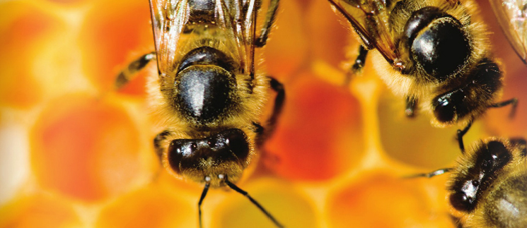
Biologists have found over 150 different chemical residues in bee pollen, a deadly “pesticide cocktail”. The chemical companies that produce these pesticides, Bayer, Syngenta, BASF, Dow, DuPont and Monsanto, claim that they don’t understand why there is a problem. They advocate no change in pesticide policy. After all, selling poisons to the world’s farmers is profitable.
Furthermore, wild bee habitat shrinks every year as industrial agribusiness converts grasslands and forest into monoculture farms, which are then contaminated with pesticides. To reverse the world bees decline, we need to fix our dysfunctional and destructive agricultural system.

Bee Collapse
Apis mellifera—the honey bee, native to Europe, Africa and Western Asia—is disappearing around the world. Signs of decline also appear now in the eastern honey bee, Apis cerana.
Honey bees—wild and domestic—perform about 80 percent of all pollination worldwide. A single bee colony can pollinate 300 million flowers each day. Grains are primarily pollinated by the wind, but the best and healthiest foods, fruits, nuts and vegetables, are pollinated by bees. Seventy out of the top 100 human food crops, which supply about 90 percent of the world’s nutrition, are pollinated by bees.
The European Commissioner for Health and Consumer Policy, calculates that bees contribute more than $30 billion dollars annually to European agriculture. Worldwide, bees pollinate human food valued at more than $350 billion. The bee collapse is a challenge to human economy on the scale of global warming, ocean acidification and nuclear war. Humans could not likely survive a total bee collapse.
Worker bees (females) live several months. Colonies produce new worker bees continuously during the spring and summer, and then reproduction slows during the winter. Typically, a bee hive or colony will decline by five to 10 percent over the winter and replace those lost bees in the spring. In a bad year, a bee colony might lose 15-20 percent of its bees.
In the U.S., where colony collapse first appeared, winter losses commonly reached 30-50 percent. In 2006, David Hackenberg, a bee keeper for 42 years, reported a 90 percent die-off among his 3,000 hives. U.S. National Agriculture Statistics show a honey bee decline from about 6 million hives in 1947 to 2.4 million hives in 2008, a 60 percent reduction.
The number of working bee colonies per hectare provides an important measurement of crop health. In the U.S., among crops that require bee pollination, the number of bee colonies per hectare has declined by 90 percent since 1962. The bees cannot keep pace with the winter die-off rates and habitat loss.
Europe Responds, U.S. Delays
In Europe, Asia and South America, the annual die-off is lower than the US, but the trend is clear, and the response is more appropriate. In Europe, annual die-offs have reached 30-35 percent and that the colonies-per-hectare count is down 25 percent. In the 1980s, in Sichuan, China, pear orchard pesticides obliterated local bees, and farmers must now pollinate crops by hand with feather dusters.
A European Food Safety Authority report determined that three widely used nicotine-based pesticides pose “high acute risks” for bees. These neonicotinoid pesticides—used in soils, on foliage and embedded in seeds—persist at the core of the toxic pesticide cocktail found in bee hives.
A Greenpeace scientific report identifies seven priority bee-killer pesticides—including three nicotine culprits. The three neonicotinoids act on insect nervous systems. They accumulate in individual bees and within entire colonies, including the honey that bees feed to infant larvae. Bees that do not die outright, experience sub-lethal systemic effects, development defects, weakness and loss of orientation. The die-off leaves fewer bees and weaker bees, who must work harder to produce honey in depleted wild habitats. These conditions create the nightmare formula for bee colony collapse.
Bayer and Syngenta make and market three other chemical pesticides. In 2009, the world market for these three toxins reached over $2 billion. Syngenta, Bayer, Dow, Monsanto and DuPont control nearly 100 percent of the world market for genetically engineered (GE) pesticides, plants and seeds.
In 2012, a German court criminally charged Syngenta with perjury for concealing its own report showing that its genetically modified corn had killed livestock. In the U.S., the company paid out $105 million to settle a class-action lawsuit for contaminating the drinking water for more than 50 million citizens with its “gender-bending” herbicide Atrazine. Now, these corporate polluters are waging multi-million-dollar campaigns to deny responsibility for bee colony collapse.
In May, the European Commission responded, adopting a two-year ban on the three neonicotinoid pesticides. Scientists will use the two years to assess the recovery rate of the bees and a longer-term ban on these and other pesticides.
Meanwhile, the U.S. supports the corporations that produce and market the deadly pesticides. In May, as European nations took action, the U.S. Environmental Protection Agency (EPA) approved the neonicotinoid pesticides, in spite of a U.S. Department of Agriculture report warning about the dangers of the bee colony collapse.
Also in May 2013, President Obama, signed the “Monsanto Protection Act“—written by Monsanto lobbyists—that gives biotech companies immunity in federal U.S. courts from damages to people and the environment caused by their commercial compounds.
Solutions Exist
Common sense actions could restore and protect the world’s bees. Experienced bee keepers, apiculturists, farmers, the European Commission and the Greenpeace report, Bees in Decline have outlined these solutions:
- Ban the seven most dangerous pesticides
- Protect pollinator health by preserving wild habitat
- Restore ecological agriculture

Ecological farming is the over-arching new policy trend that will stabilize human food production, preserve wild habitats and protect the bees. Ecological or organic farming, of course, is nothing new. It is the way most farming has been done throughout human history. Ecological farming resists insect damage by avoiding large monocultures and preserving ecosystem diversity. Ecological farming restores soil nutrients with natural composting systems, avoids soil loss from wind and water erosion, and avoids pesticides and chemical fertilizers.
By restoring bee populations and healthier bees, ecological agriculture improves pollination, which in turn improves crop yields. Ecological farming takes advantage of the natural ecosystem services, water filtration, pollination, oxygen production and disease and pest control.
Organic farmers have advocated better research and funding by industry, government, farmers and the public to develop organic farming techniques, improve food production and maintain ecological health. The revolution in farming would promote equitable diets around the world and support crops primarily for human consumption, avoiding crops for animal food and biofuels.
Ecosystems
The plight of the bees serves as a warning that we still may not quite understand ecology. Ecological farming is part of a larger paradigm shift in human awareness. Large pesticide corporations refuse to recognize that Earth’s systems operate within real limits. They cling to the presumed right to consume, hoard, and obliterate Earth’s great bounty for private profits. But all of the money in the world won’t reverse extinction, restore lost soils or heal the world’s bee colonies.
The Earth is in big trouble if this situation is not fixed. Earth’s delicately balanced systems can reach tipping points and collapse. Bees, for example, work within a limited range of marginal returns on the energy they exert to collect nutrition for their colonies. When winter bee deaths grow from 10 percent to 50 percent, the remaining bees are weakened by toxins, and the wild habitats shrink, the ecological margin of energy return can be squeezed to zero. Surviving bees expend more energy than they return in honey. More bees die, fewer reach maturity and entire colonies collapse. This crisis is a lesson in fundamental ecology.
Ecologists and environmentalists have warned of this problem for 50 years. Bee colony collapse now joins global warming, forest destruction and species extinctions among our most urgent ecological emergencies. Saving the world’s bees appears as one more necessary link in restoring Earth to ecological balance.

Adapted from
http://ecowatch.com/2013/06/11/worldwide-honey-bee-collapse-a-lesson-in-ecology/

- Using information from the article, try to answer any remaining questions.

- Evaluate the author’s purpose for writing this article. How is the purpose of the video different from that of the article? How are they similar?

- Give the students a chance to process the information and then ask them to write a paragraph about Colony Collapse Disorder including answers to the following questions.
- What is Colony Collapse Disorder?
- What is causing CCD?
- Why should humans care about CCD?
- What can be done to reverse CCD?

- Summary Exercise (Worksheet) – Choose the best summary for today’s lesson and explain why the other two summaries are not accurate.

Which is the best summary of today’s lesson? Why?

1. Bees and plants have a mutual symbiotic relationship. Flowers produce pollen which the bees use for food, and the bees carry pollen from flower to flower so that the flowers can reproduce and form seeds for new plants. Because there aren’t enough flowers for the bees to make food, the bees are dying off. The best way to solve this problem is to plant more flowers.
2. Over the past 40 years, there has been a rapid decline in the number of bees world-wide. It is believed that loss and disruption of habitats, widespread use of multiple pesticides, and mite infestations in the beehives, have caused Colony Collapse Disorder, or the death of bee colonies. Many fruit and vegetable crops are dependent on bees for pollination, and with the loss of bees, these crops will produce less. This could cause a rise in produce costs, and create global food shortages
3. Large numbers of fruit and vegetable crops are disappearing because there aren’t enough bees to pollinate them. The bees are dying because they are being poisoned with chemical pesticides. European nations have banned the use of pesticides, but in the United States, the pesticide companies are still profiting from sales of the toxic chemicals. Use of deadly pesticides is causing Colony Collapse Disorder.

Extension activities:
How does this quotation illustrate a symbiotic relationship? “For bees, the flower is the fountain of life. For flowers, the bee is the messenger of love.”

Three infographics (Worksheet) – Relying on Bees, Dependence of crops on honey bees for pollination, Colony losses in the US.

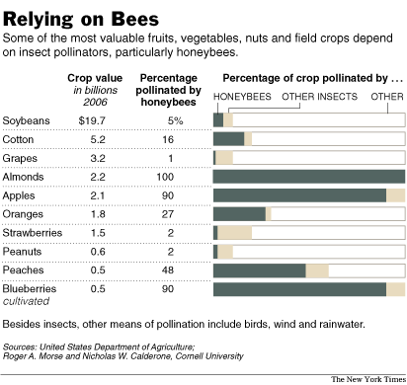

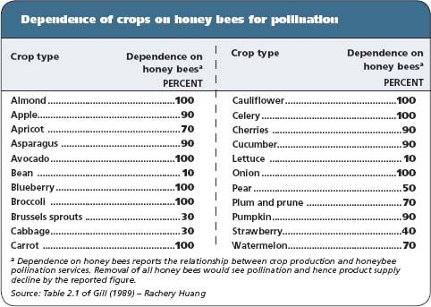

Colony Losses in the U.S.
